**Introduction**

A skilled Java developer must know how to use the language's programming concepts and syntax to develop applications. For example, it is essential to become familiar with the collections framework. Collections are a trendy and vital topic for developers; the topic is often brought up even at job interviews. How important is it? Well, without the concept of collections, it is impossible to develop a software app.

**What Are Collections?**

Java is a language that is good for managing large volumes of information, which needs to be stored somewhere. Mainly, it is stored in:

* Arrays
* Common objects
* Collections

What is special about collections? Unlike other types of storage, collections store large amounts of homogenous information and offer a widely branched interface for managing it. *Collections* can be defined as follows:

**Collections** are storages or containers providing a variety of ways to store and organize groups of objects for easy, efficient access. They are implementations of abstract data structures that support three basic operations:

* Adding a new element
* Removing an element
* Searching for an element

They are also used in replacement, viewing and counting elements, and enumeration.

Collections are used to process large volumes of information. Imagine a large online store with about 40 thousand products, 125 million customers, and 400 million orders. When the number of objects is in the hundreds of thousands, arrays can no longer provide the proper speed or resource savings. Collections help keep performance high and save resources.

**Collections in Java Versions**

Collections and how they are organized have changed over time. In Java 1, the library contained classes for working with elementary data structures: Vector, Stack, Hashtable, and BitSet. Also, Java 1 included the Enumeration interface for working with elements of these classes. Collections introduced in Java 2 presented a unified approach to storing and accessing dataset objects called the collections framework. Starting with Java 5, collections are **typed**, allowing users to:

* Inform the compiler about the object types stored in the collection
* Check the correctness of work with object types at the compilation stage
* Avoid having to call the type of returned object by an object reference to the required type (because the compiler is already aware of the object type)

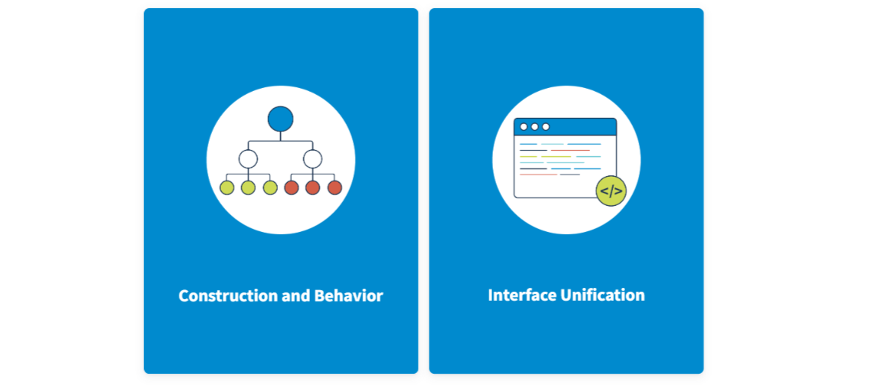

As a set of interfaces, the collections framework forces the user to accept a specific construction and behavior of datasets (groups of objects).

As a set of interfaces, the collections framework forces the user to accept a specific construction and behavior of datasets (groups of objects).

The collections framework has the following components:

* A set of interfaces
* A set of classes and implementing interfaces
* A set of algorithms (e.g., sorting and search)

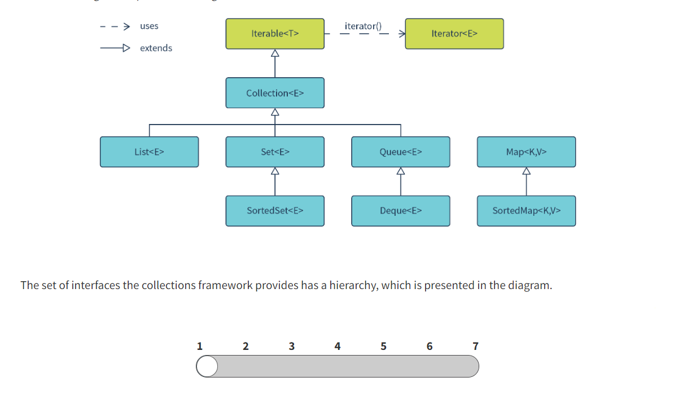

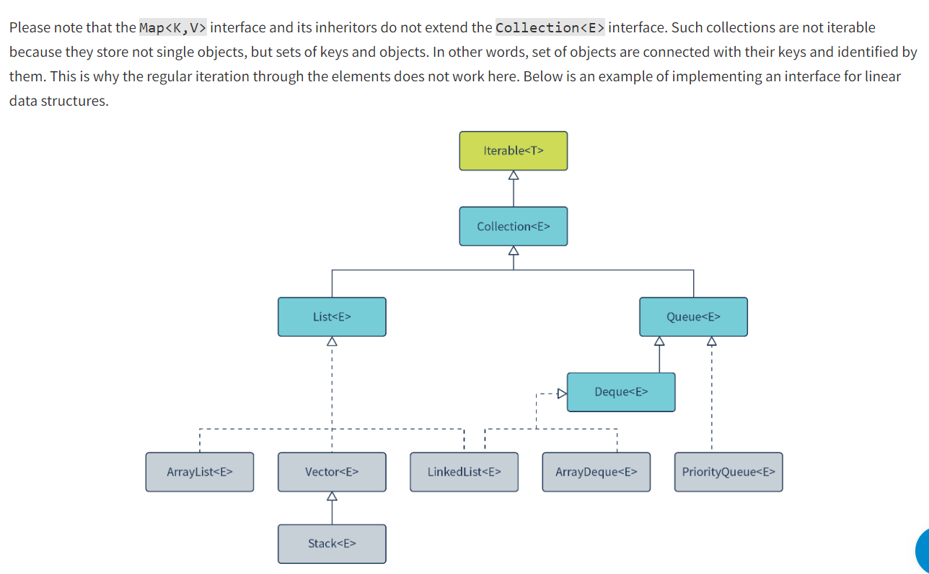

Here, you can see that the List<E> interface extends the Collection<E> interface. The ArrayList<E> and LinkedList<E> classes are implementations of these interfaces that define how an object is stored. The LinkedList<E> class implements the Queue<E> and Deque<E> interfaces, which means you can give queue properties to the list.

<https://docs.oracle.com/javase/tutorial/collections/intro/index.html>

<https://docs.oracle.com/javase/tutorial/collections/interfaces/index.html>

<https://docs.oracle.com/javase/tutorial/collections/implementations/index.html>

In this lesson, you reviewed the concepts of a collection and the collections framework. The collection hierarchy includes a number of interfaces, where each one has its purpose. So, to work with lists, you need to use the List<E> interface, with sets—the Set<E> interface, with queues—the Queue<E> interface, and with maps—the Map<K,V>

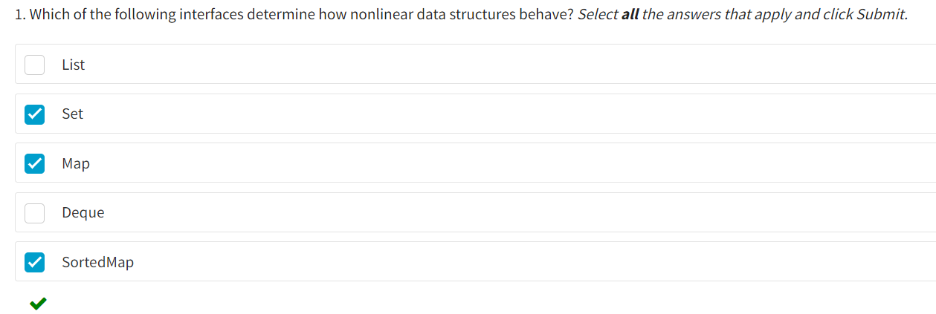

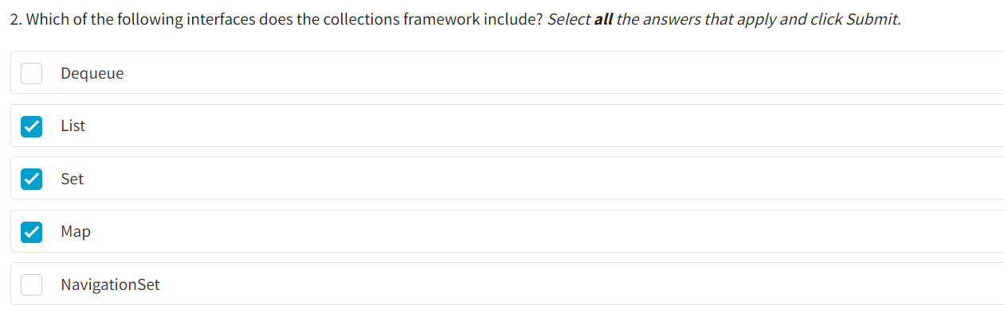

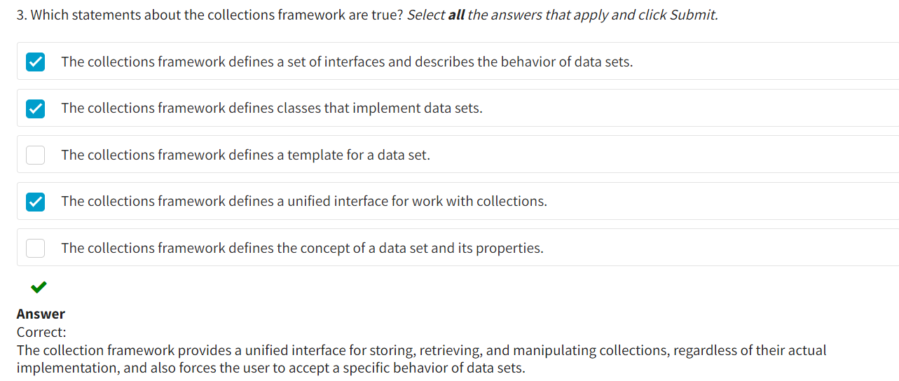

**Types of Collection Interface Operations**

The Collection<E> interface belongs to the collections framework. It is the root interface of the collection hierarchy and part of the java.util package. The Collection<E> interface contains methods describing the behavior of any collection type.

The methods of the Collection<E> interface can be divided into the following groups.

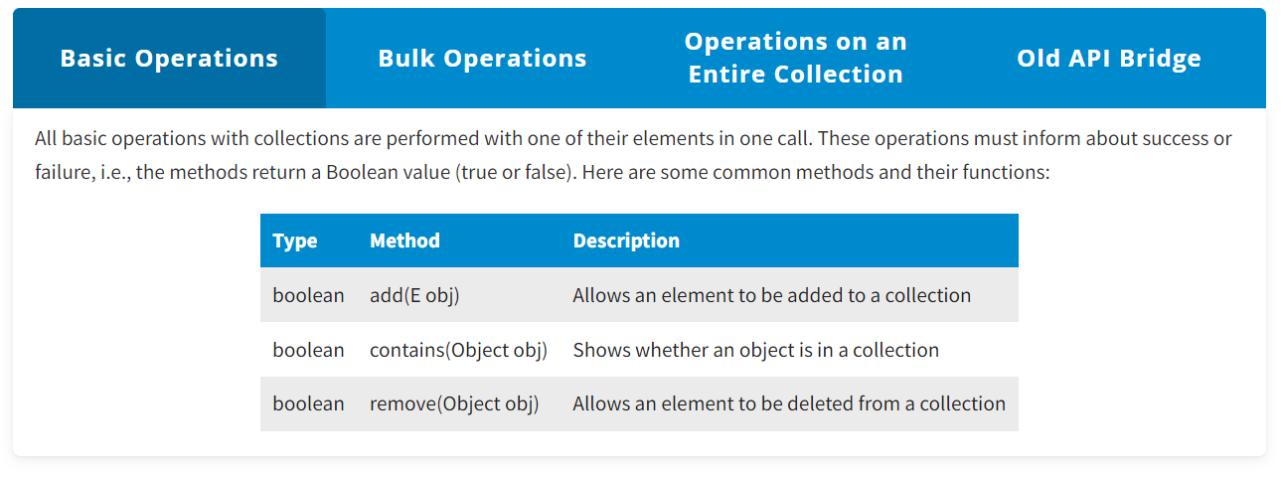

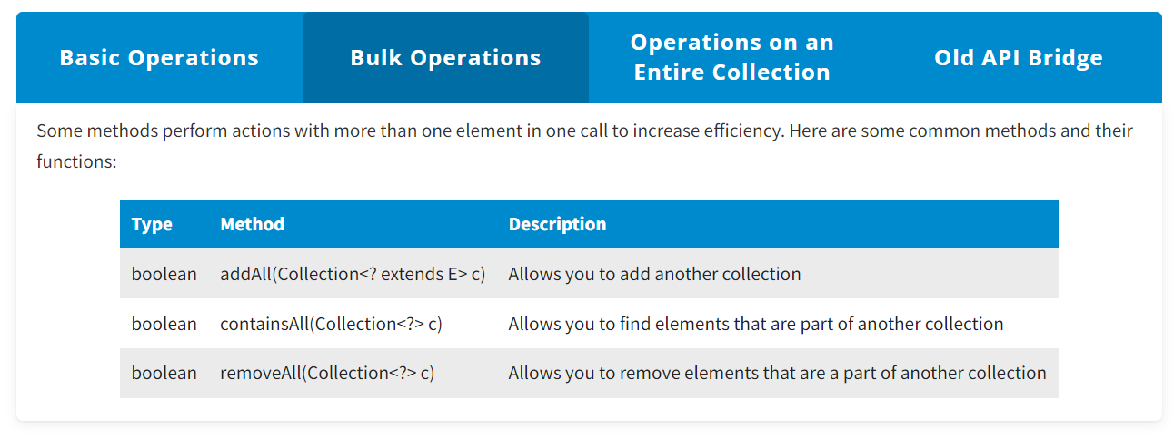

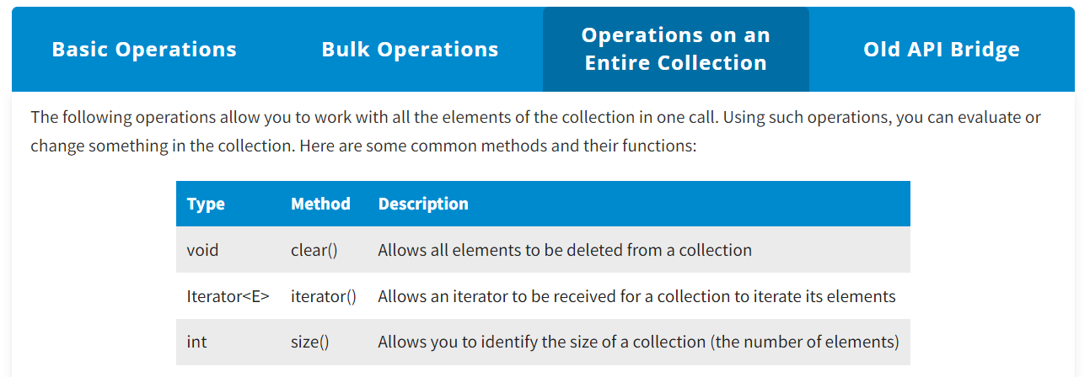

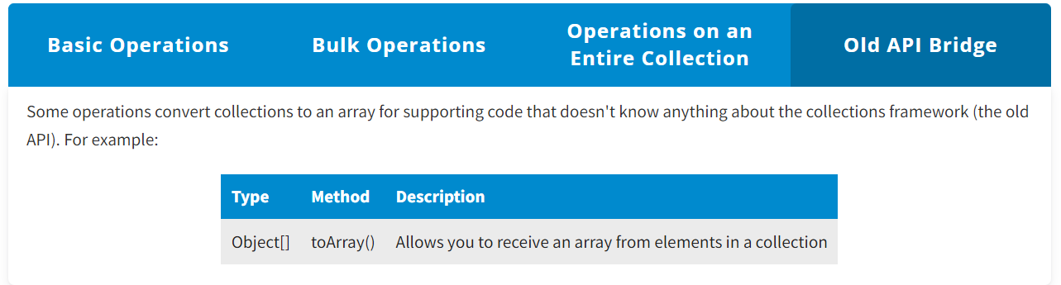

With the introduction of Java 5, collections are now generic. In other words, they can only store objects because primitive types cannot be specified as a type parameter. This generalization of collections made it possible to create homogeneous collections and avoid unsafe operations on their elements. However, you can still create collections without specifying a type parameter. These are called raw types and are used to support code that does not know anything about generics. In this case, the collection can contain data of any type. You will see how generic and raw data types are implemented on lists later in this lesson.

**Examples of Collection Interface Methods**

One feature of the collections framework is that collections are accessed through. Thus, a set of actions performed with the collection is clearly defined.

The following examples of using the Collection<E> interface methods illustrate operations with lists.

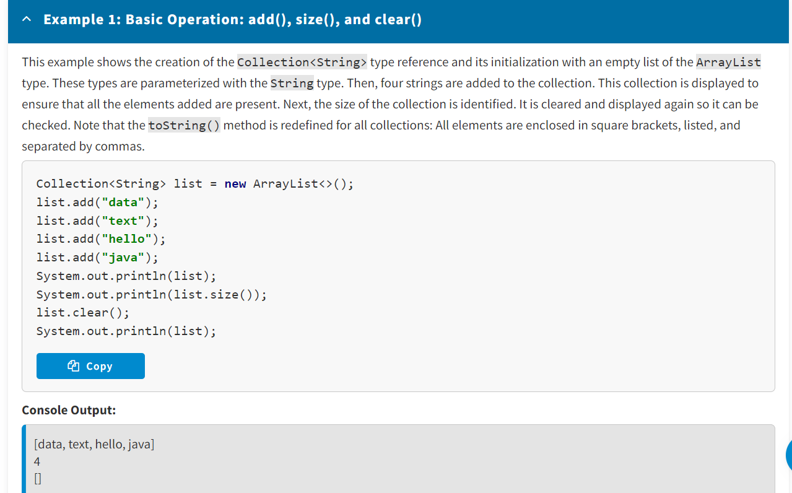

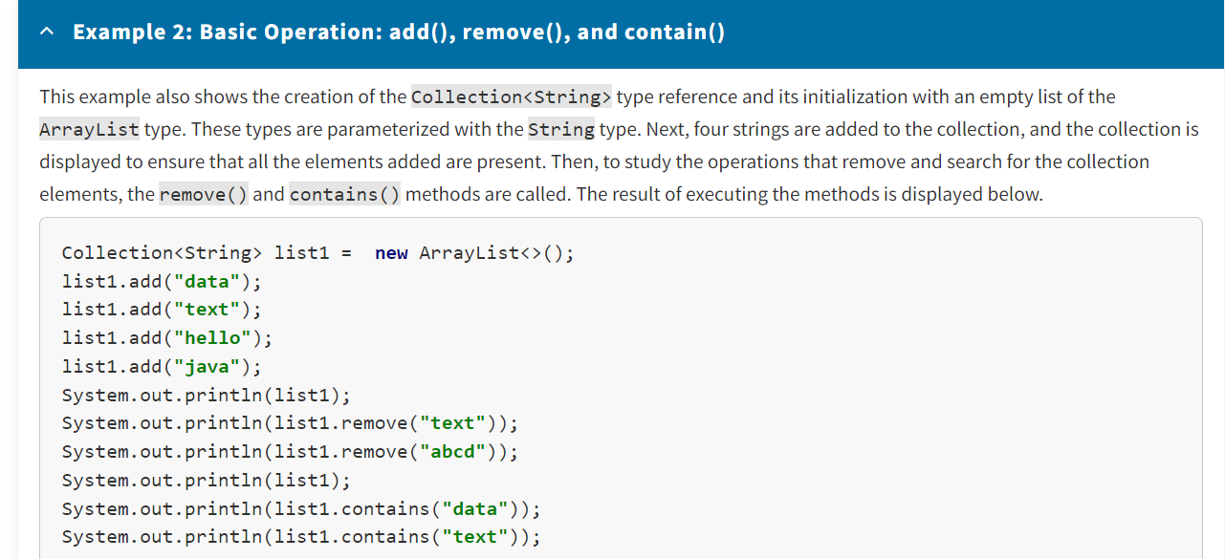

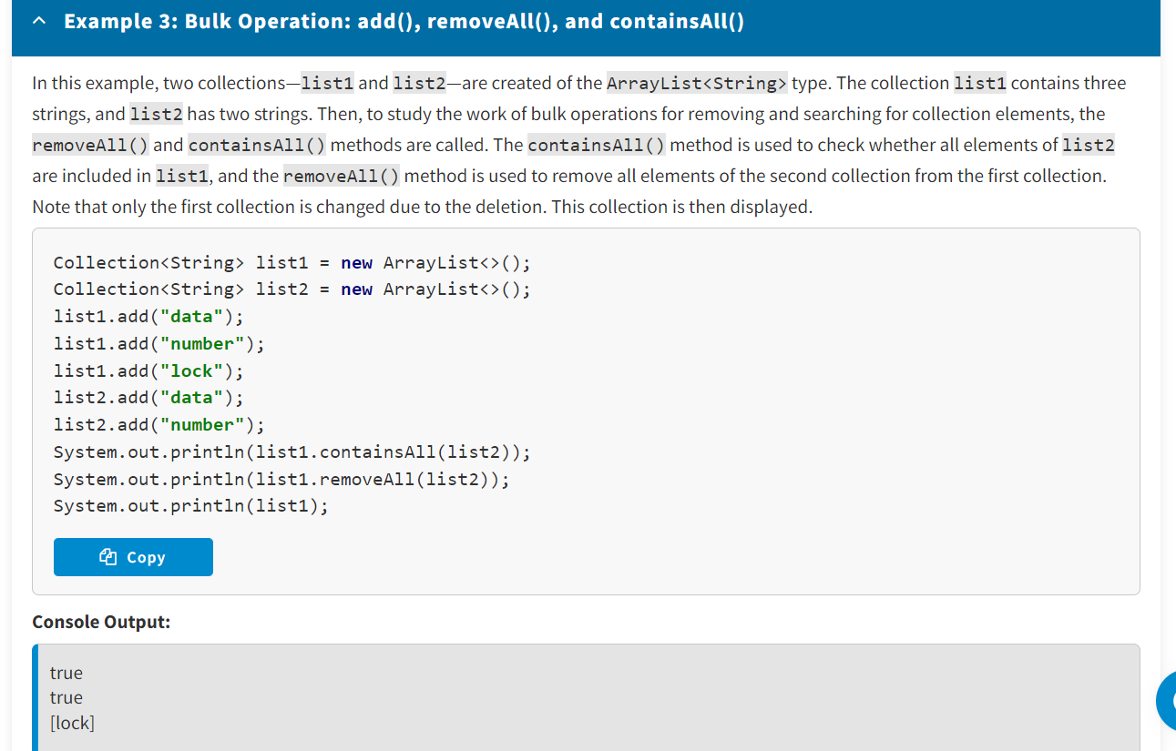

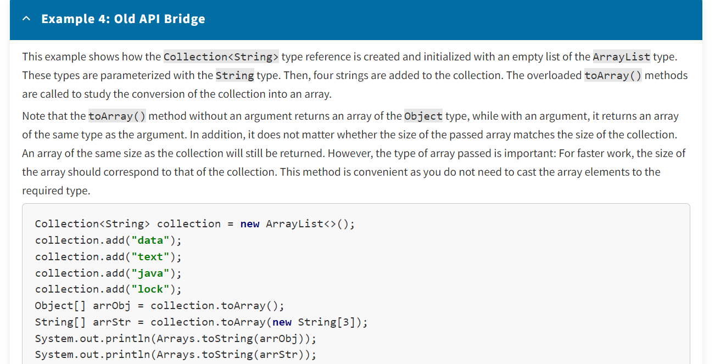

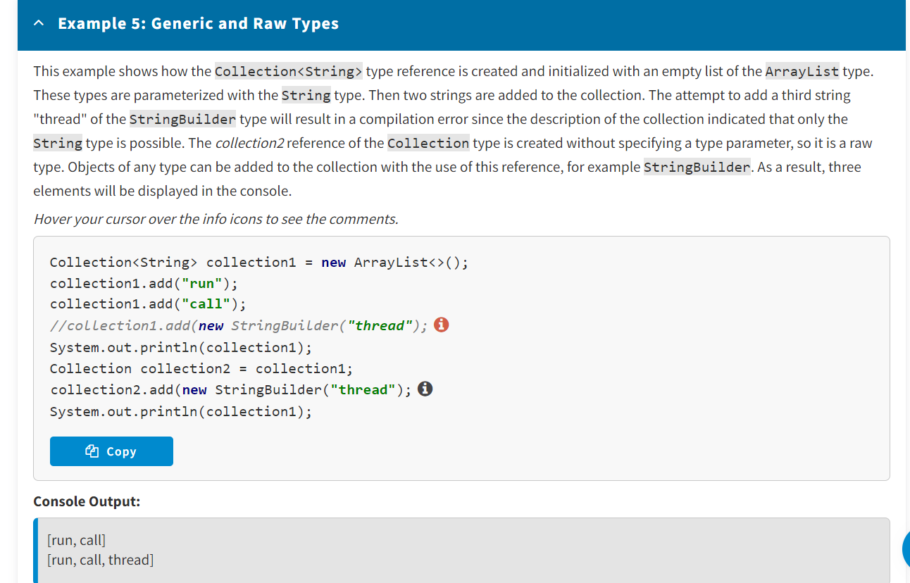

<https://docs.oracle.com/javase/tutorial/collections/interfaces/collection.html>

<https://docs.oracle.com/en/java/javase/14/docs/api/java.base/java/util/Collection.html>

**Conclusion**

The Collection<E> interface contains methods common to all collections and describes basic operations such as adding or removing an object. So, the knowledge of the methods' behaviors of the Collection<E> interface will allow you to use them effectively.

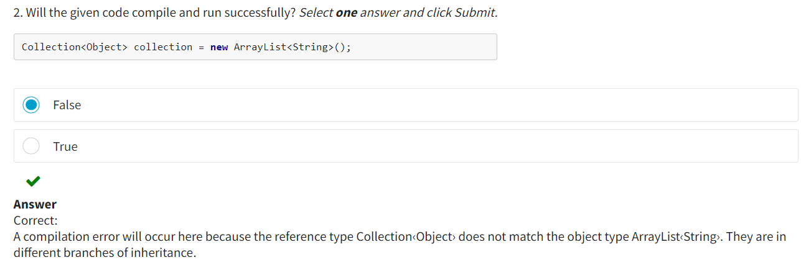

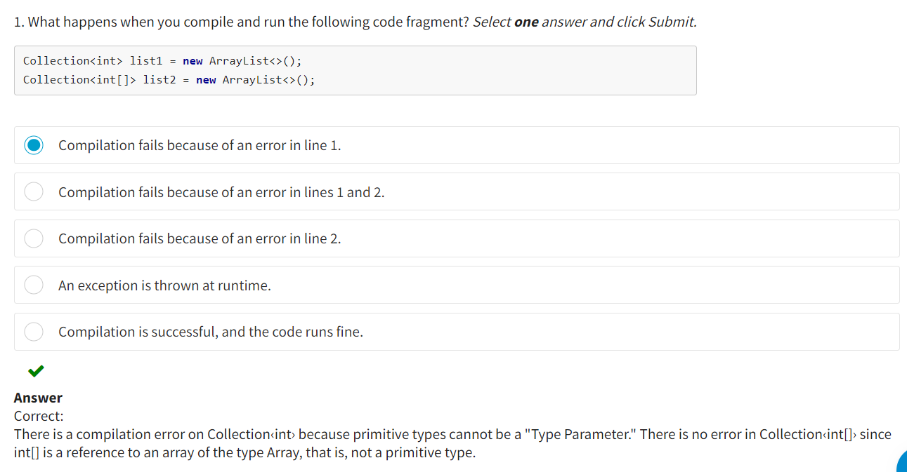

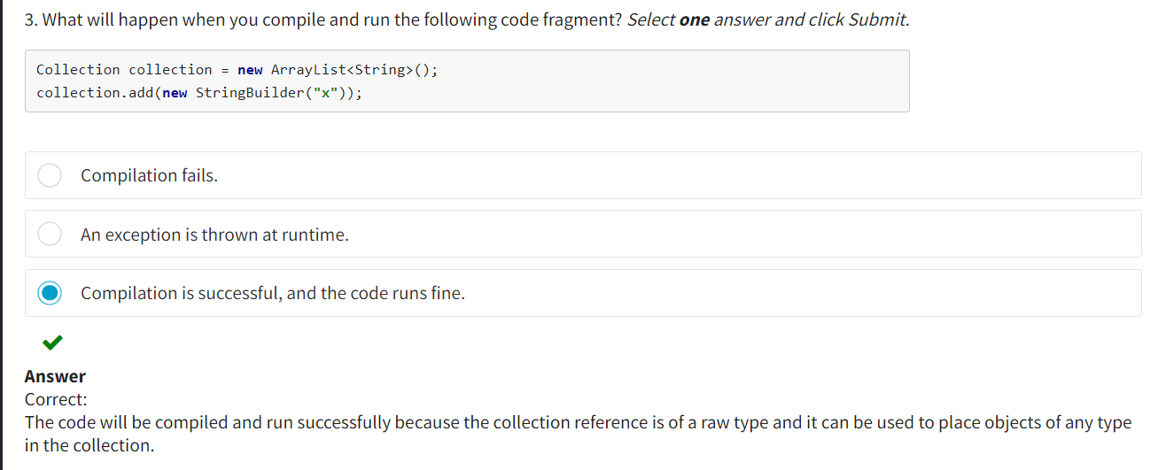

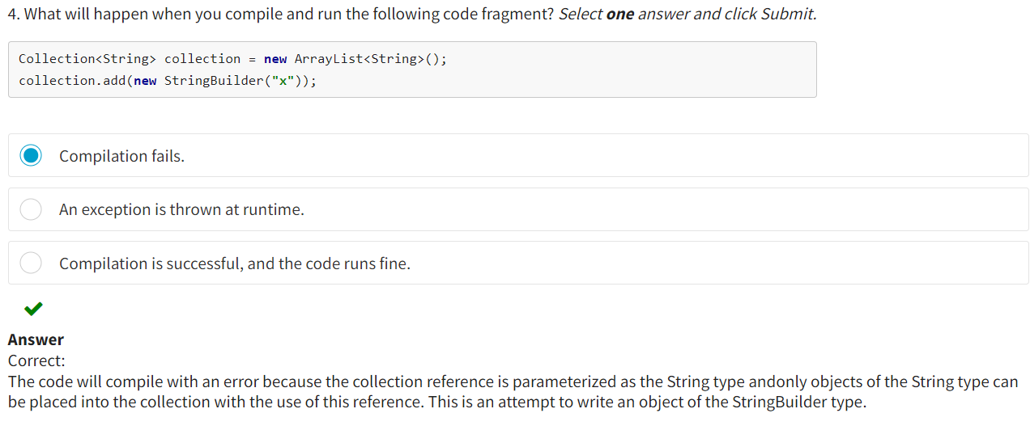

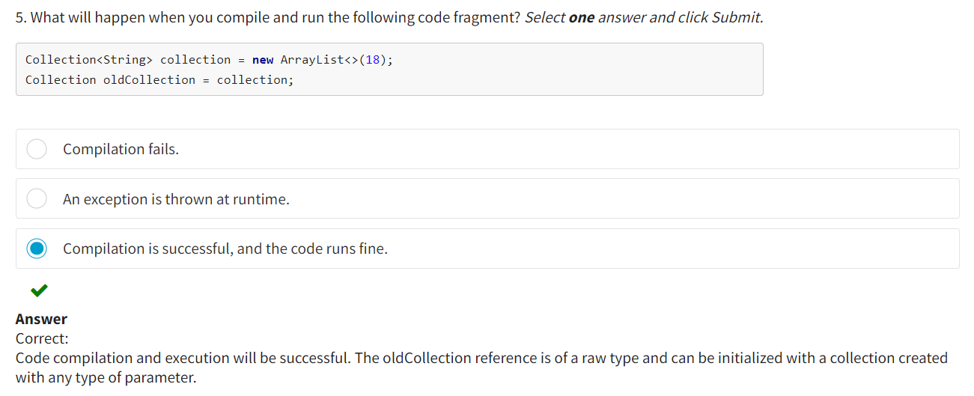

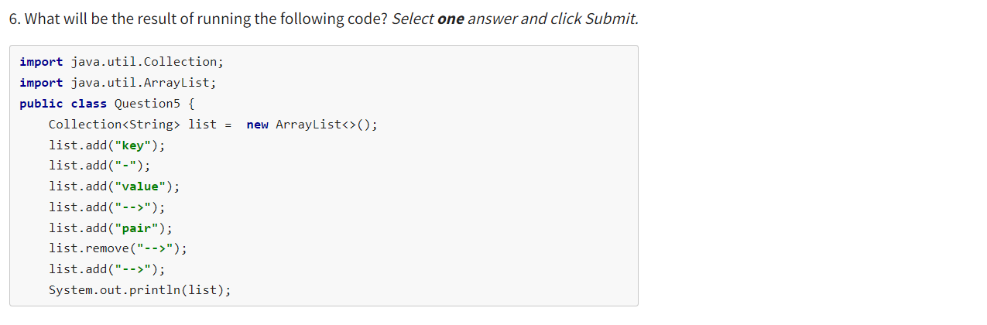

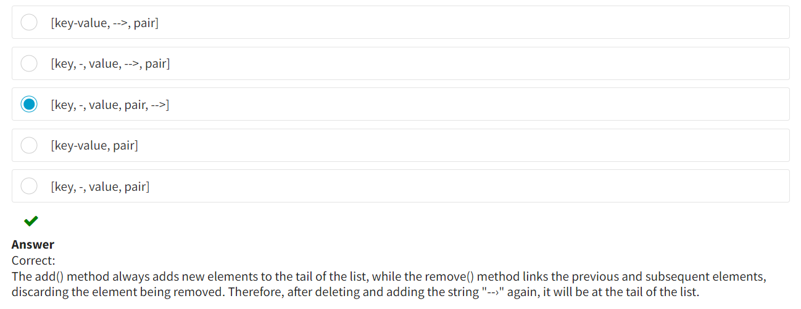

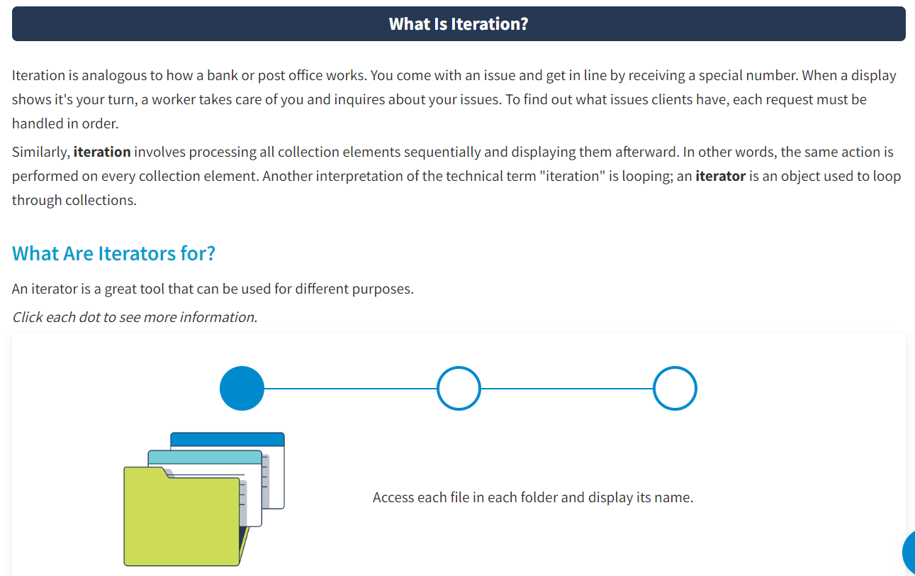

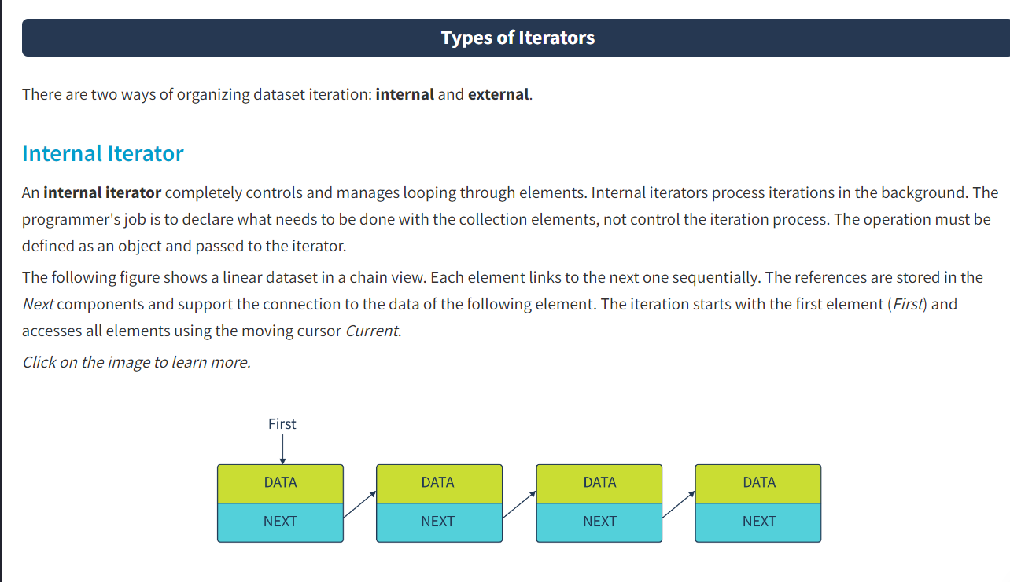

So, to implement an internal iterator, do the following:

**Step 1**: Define the operation to be performed on the dataset.  
**Step 2**: Define an iterator to receive the operation to be performed in the dataset.  
**Step 3**: Define the cursor and set it initially to the position of the first element in the dataset.  
**Step 4**: Organize the cycle for accessing the dataset elements in the iterator. This step involves two actions:  
4.1 Processing the current element  
4.2 Moving the cursor to the next element

In this example, the Task class describes an operation—the working() method. The Data class describes the objects stored in a dataset, and the DataSet class describes the dataset itself. The element description of the dataset is represented by the inner Node class. The iteration here is initialized by the iterator() method.

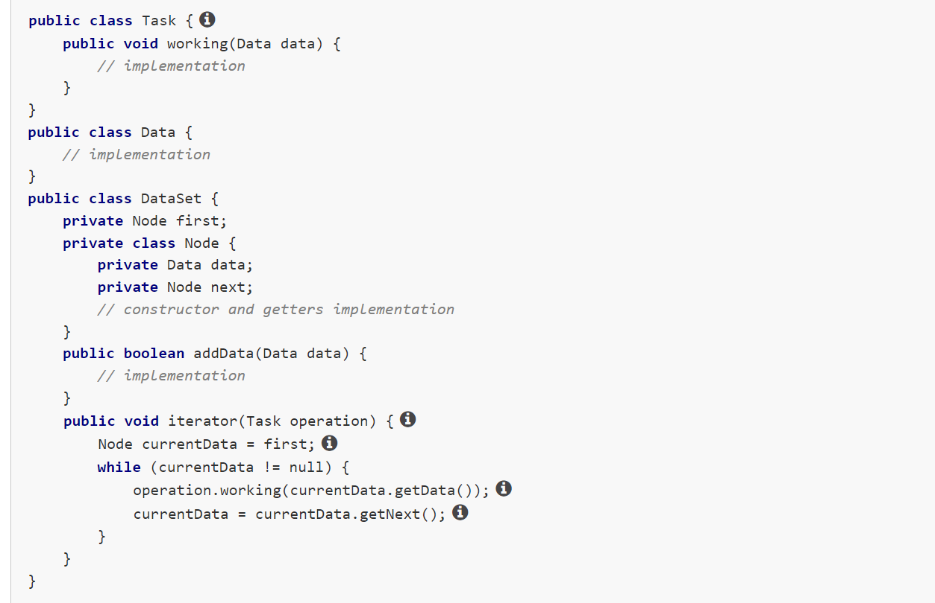

This approach has certain **limitations**:

* For each dataset processing task, you must create a separate object that implements the processing and pass it to the iterator.
* Two iterators can't work on the same dataset at once because the iterator cannot interrupt its work until all elements have been processed. So, in this approach, you cannot compare two elements in a dataset.

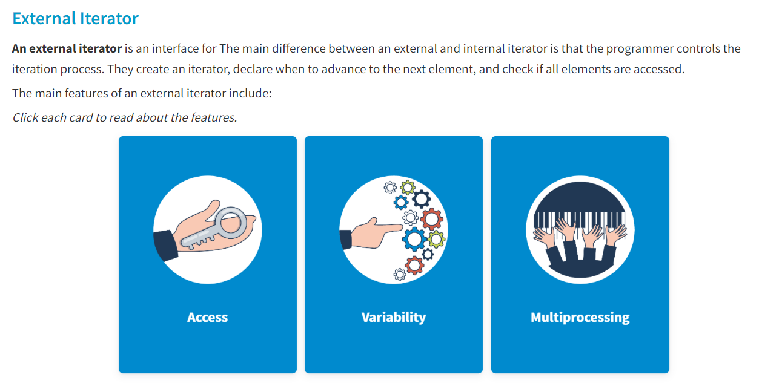

An external iterator provides sequential access to all elements of a dataset without revealing its internal structure.

An external iterator supports various types of iteration.

Multiple external iterators can iterate the same dataset simultaneously.

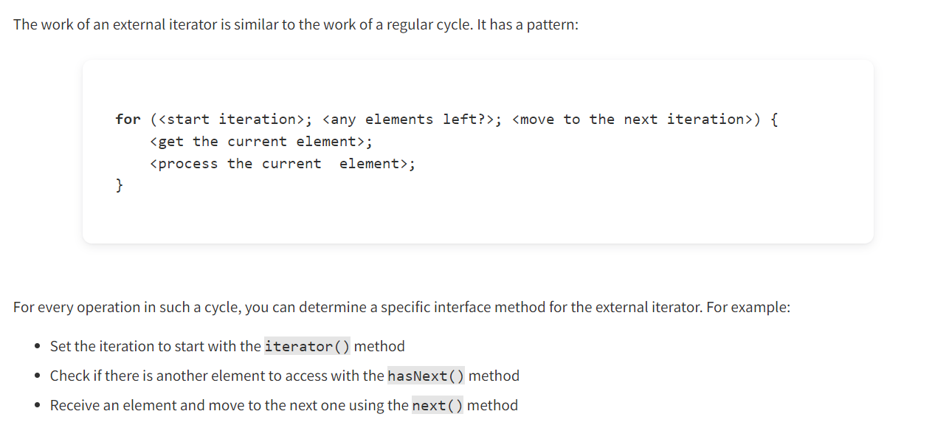

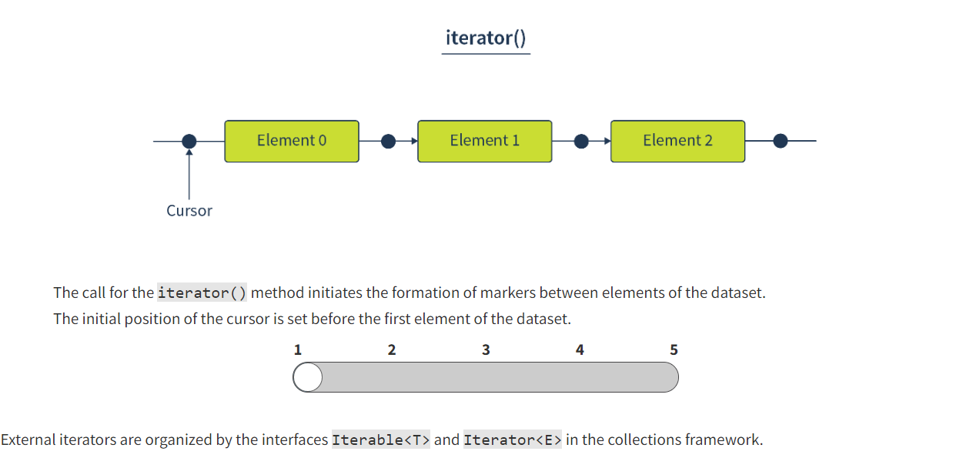

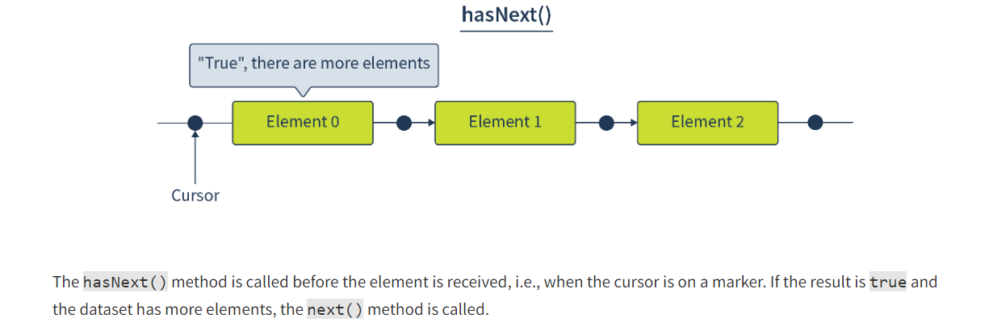

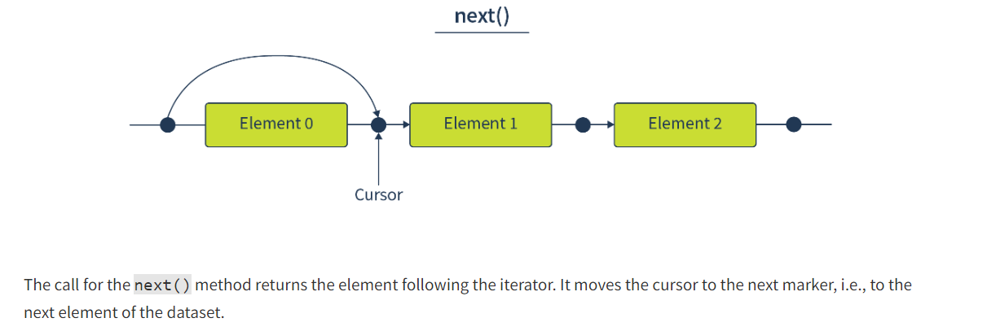

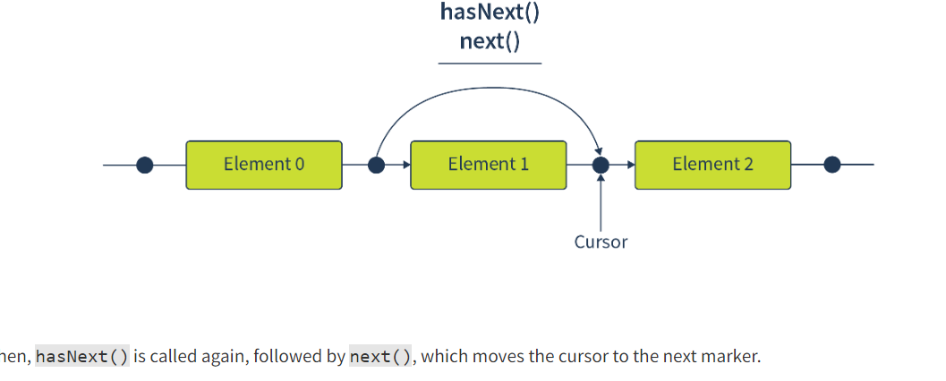

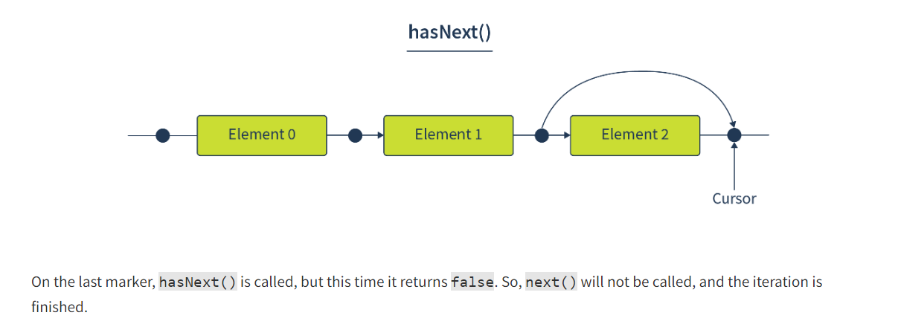

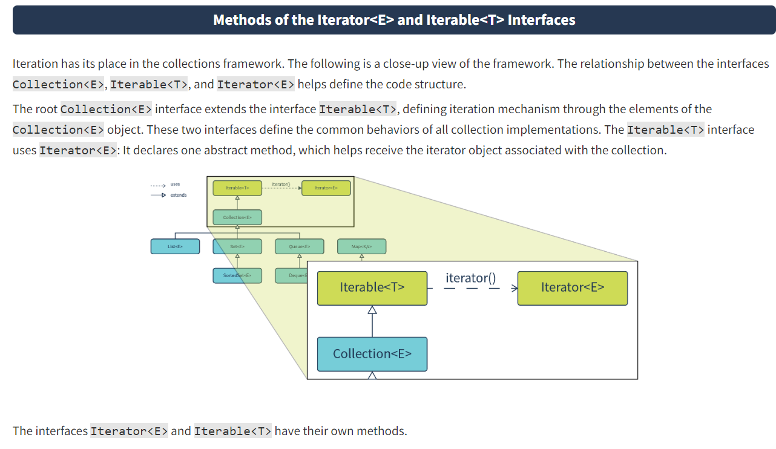

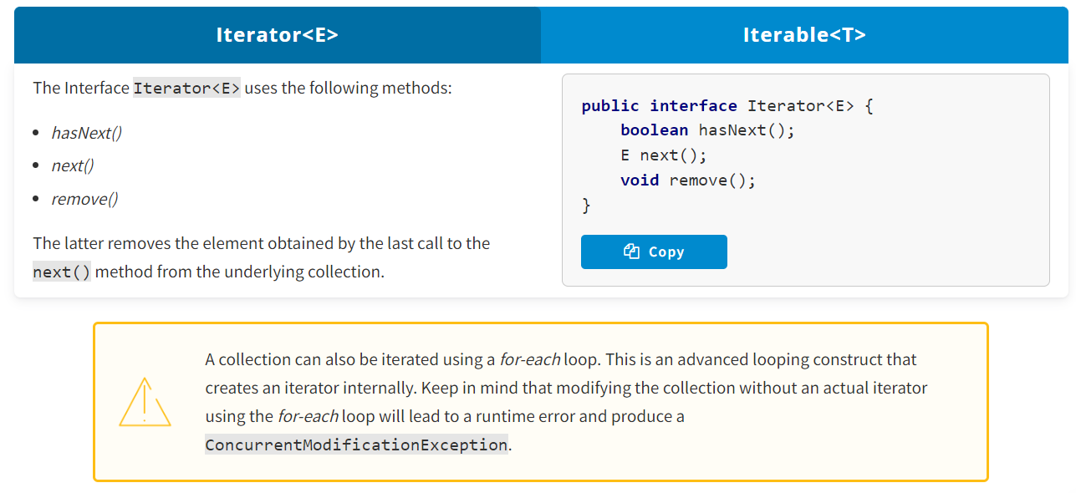

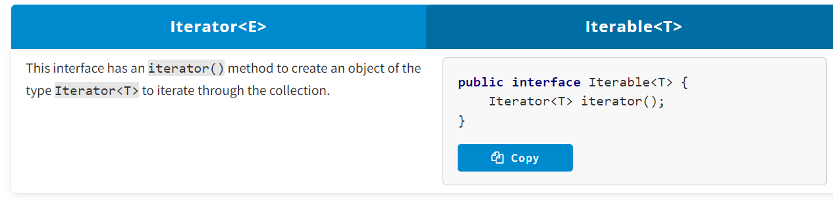

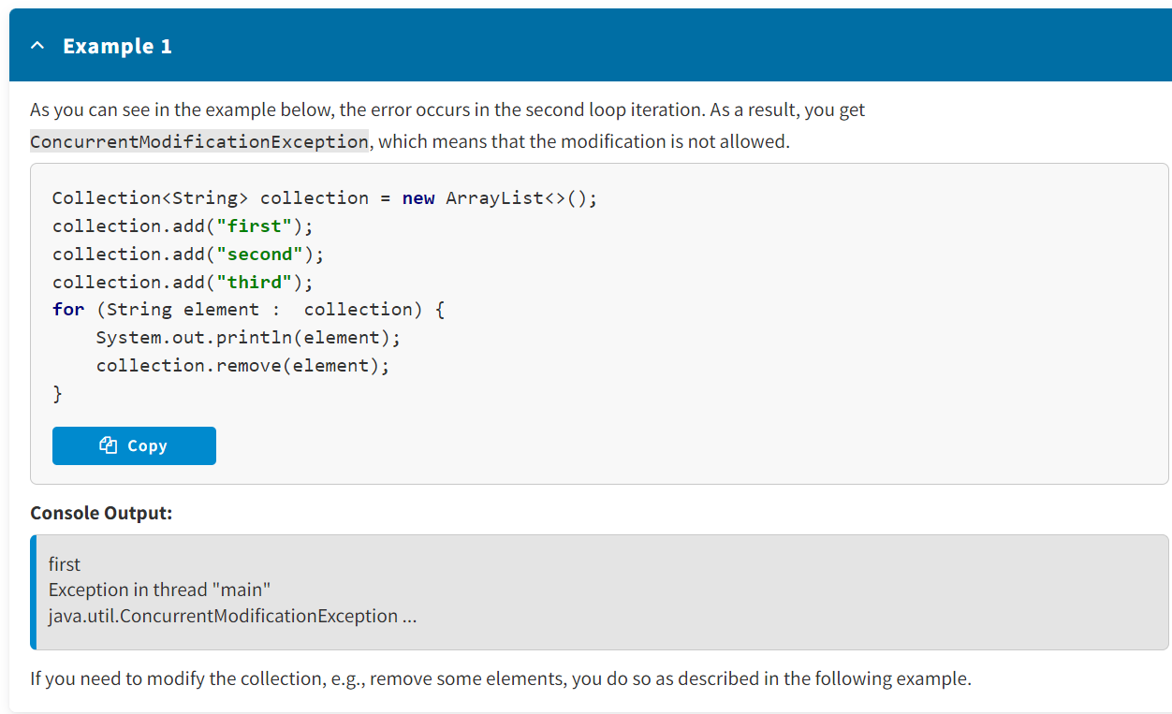

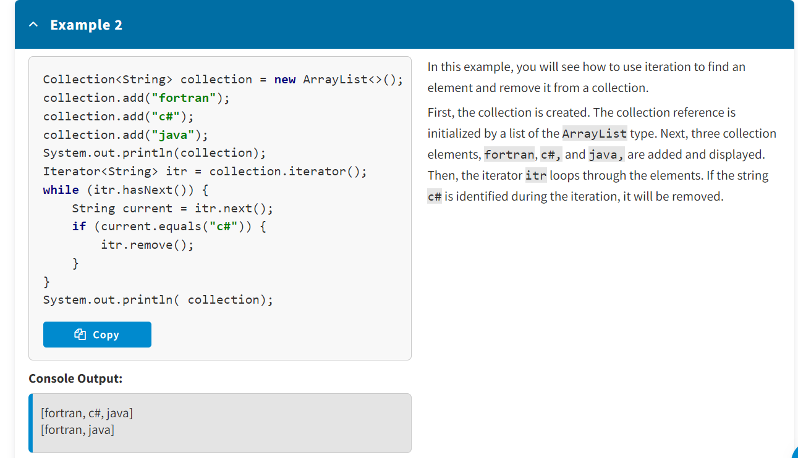

<https://docs.oracle.com/en/java/javase/17/docs/api/java.base/java/util/Iterator.html>

<https://docs.oracle.com/en/java/javase/17/docs/api/java.base/java/lang/Iterable.html>

**Conclusion**

Iterators can be internal and external. The implementation of an internal iterator depends on the structure of a dataset. It must receive a description of the operation to be performed on the elements of the dataset. An external iterator, on the other hand, provides a common interface for iterating over the elements of any dataset. This approach is more flexible for working with datasets and is implemented in the Java collections framework.

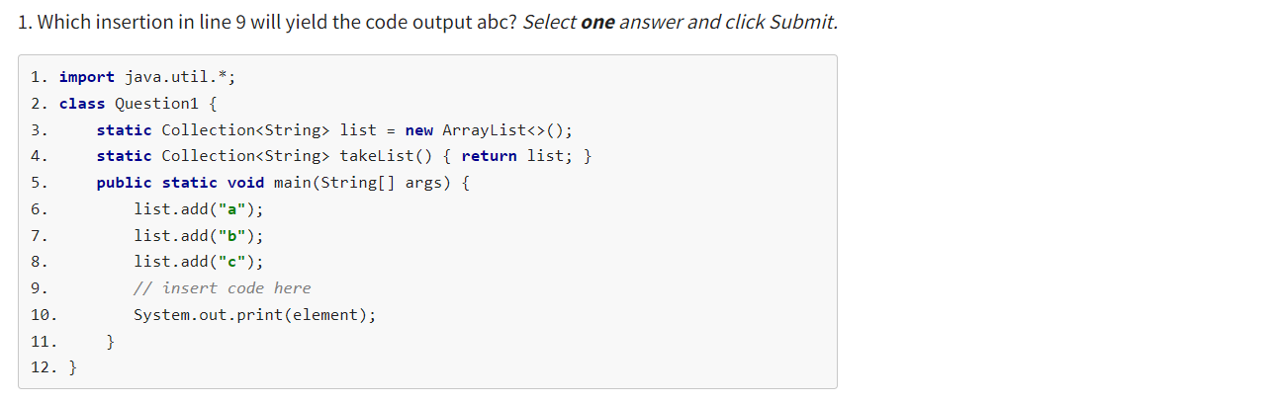

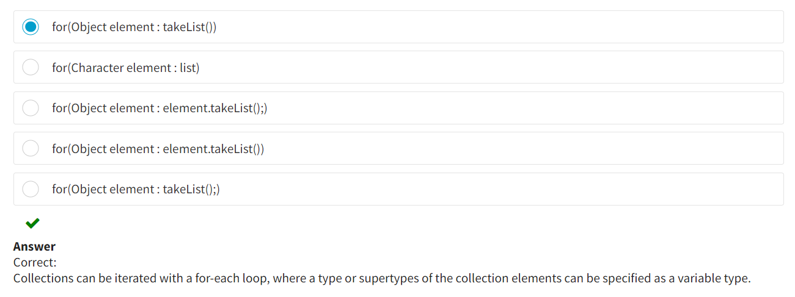

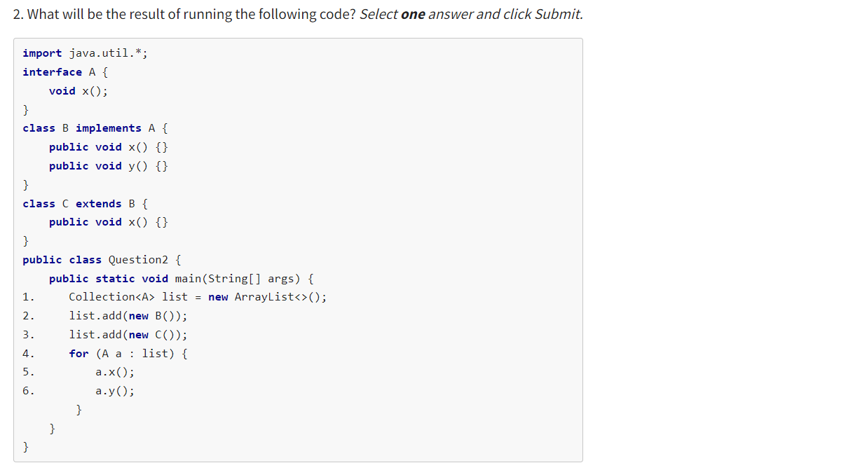

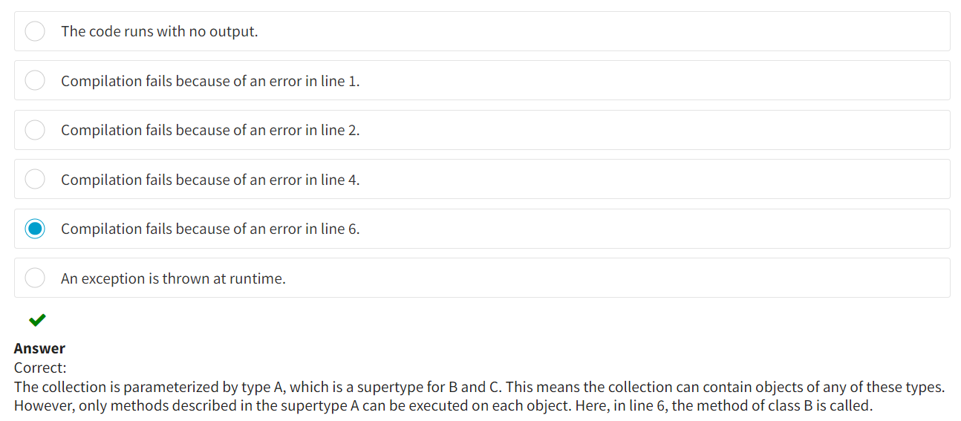

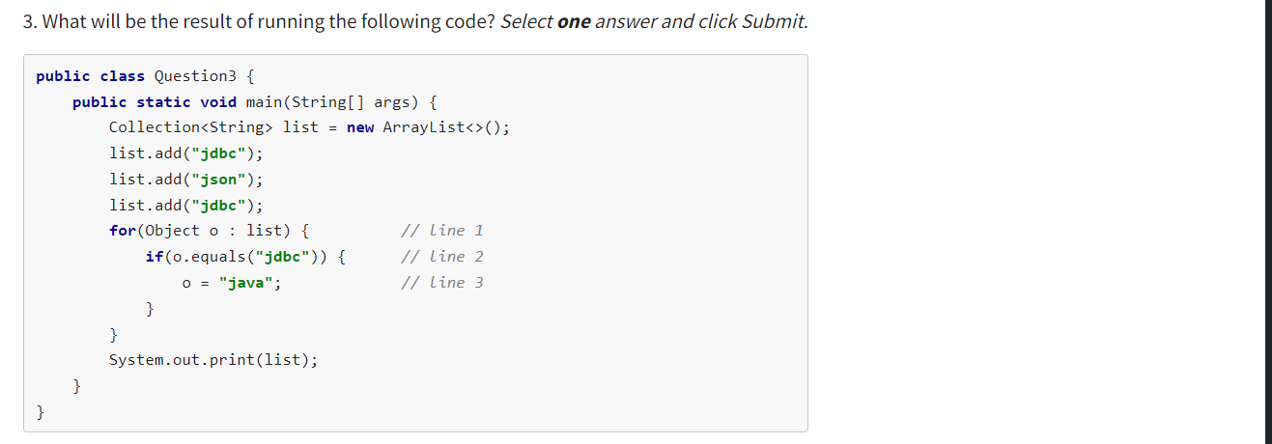

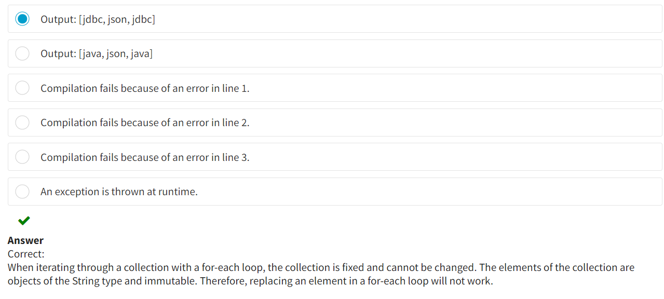

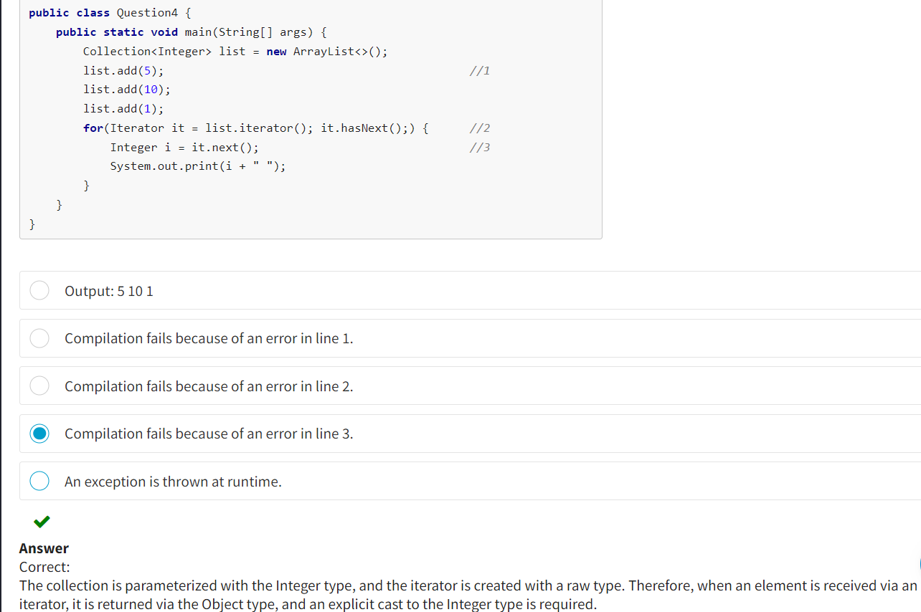

**Lists and Queues :**

**What Is a Data Structure?**

Data can be structured or unstructured. Structured data is easier to operate. A user enjoys the convenience of structured data when using online stores. Instead of endlessly scrolling in search of the book you need, you can sort or filter items based on price, reviews, or other features. Structured data helps developers implement such engines at a low cost and using simple algorithms.

In computer science, a **data structure** is a group of data that is organized in a specific way. Data structures define rules for processing the elements they are comprised of, such as different ways of storing and accessing them.

**Types of Data Structures**

The fact that data is structured implies that its elements are somehow related or connected. The nature of these relationships helps distinguish a range of features for defining types of data structures. You will get acquainted with these features.

**Order**

Order refers to the order of data elements in a structure.

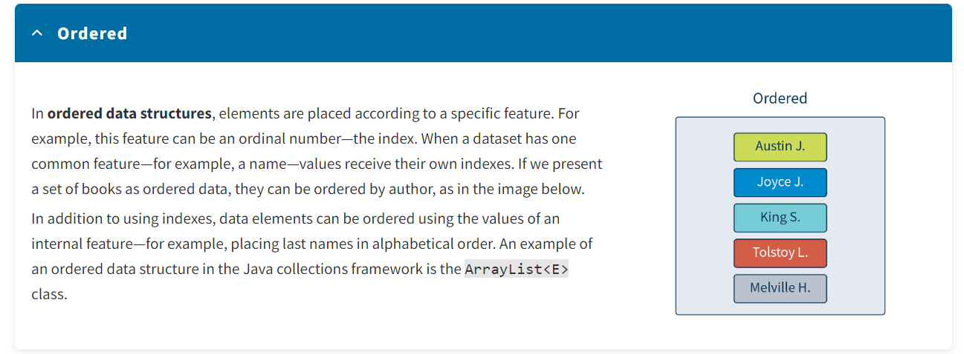

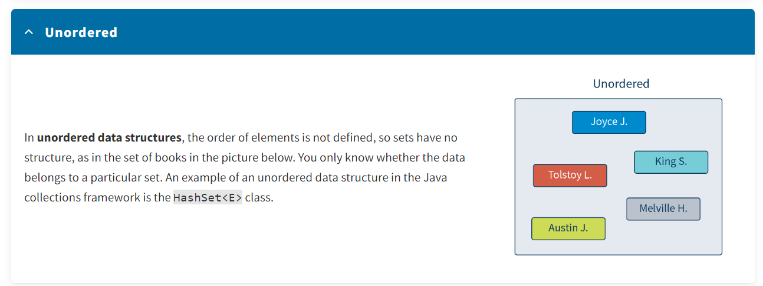

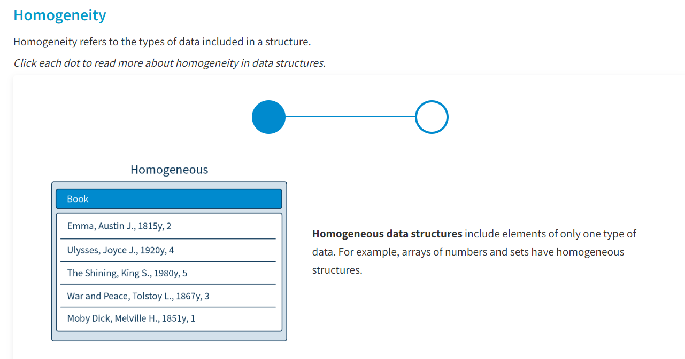

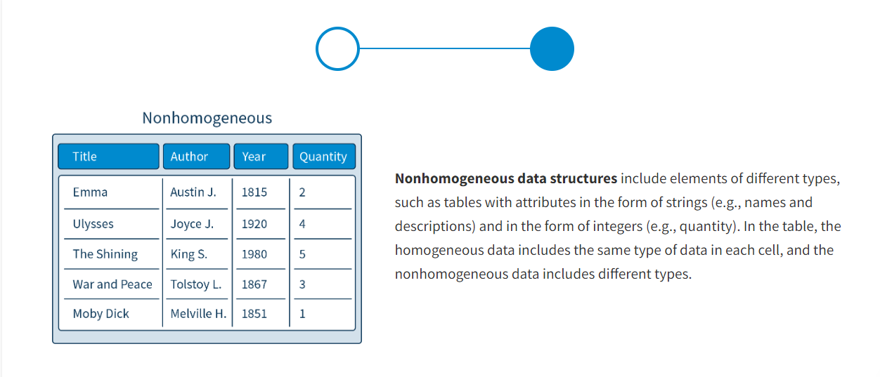

Note that before Java 5, collections could be nonhomogeneous. In Java 5 and later versions, they became homogeneous thanks to the introduction of generics. This is why when creating a collection, you need to specify the types of elements.

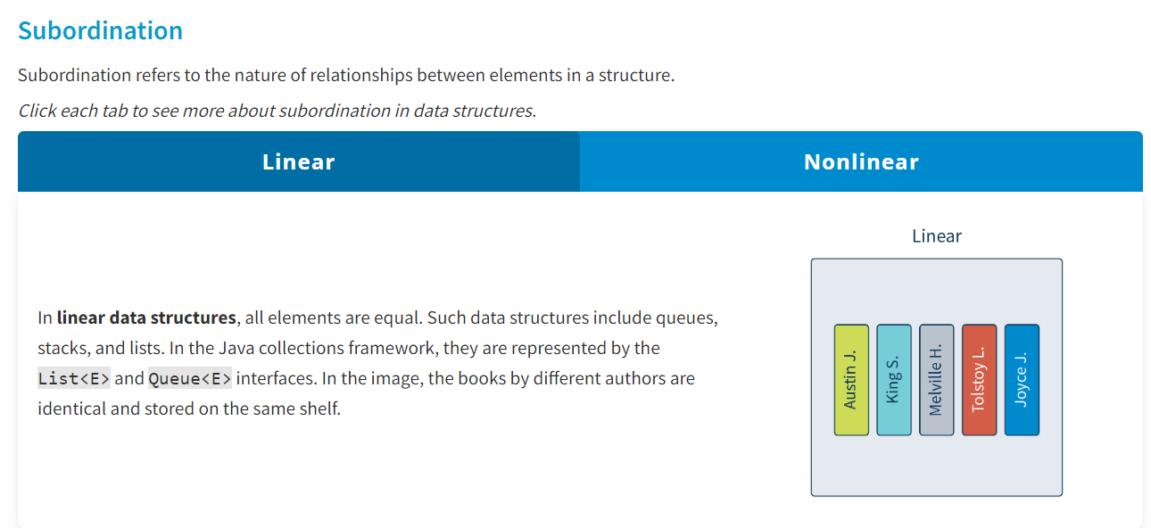

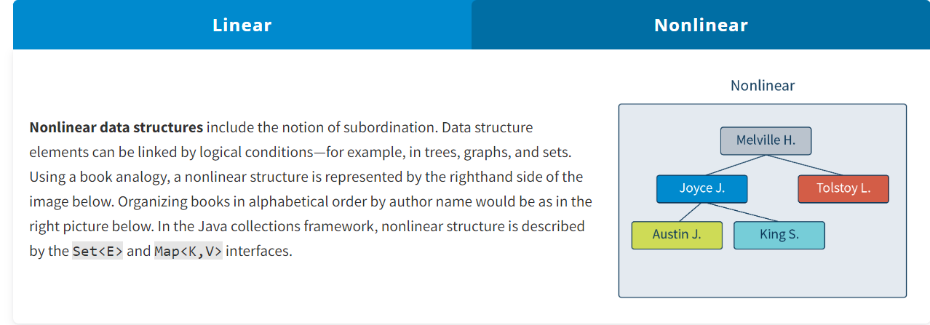

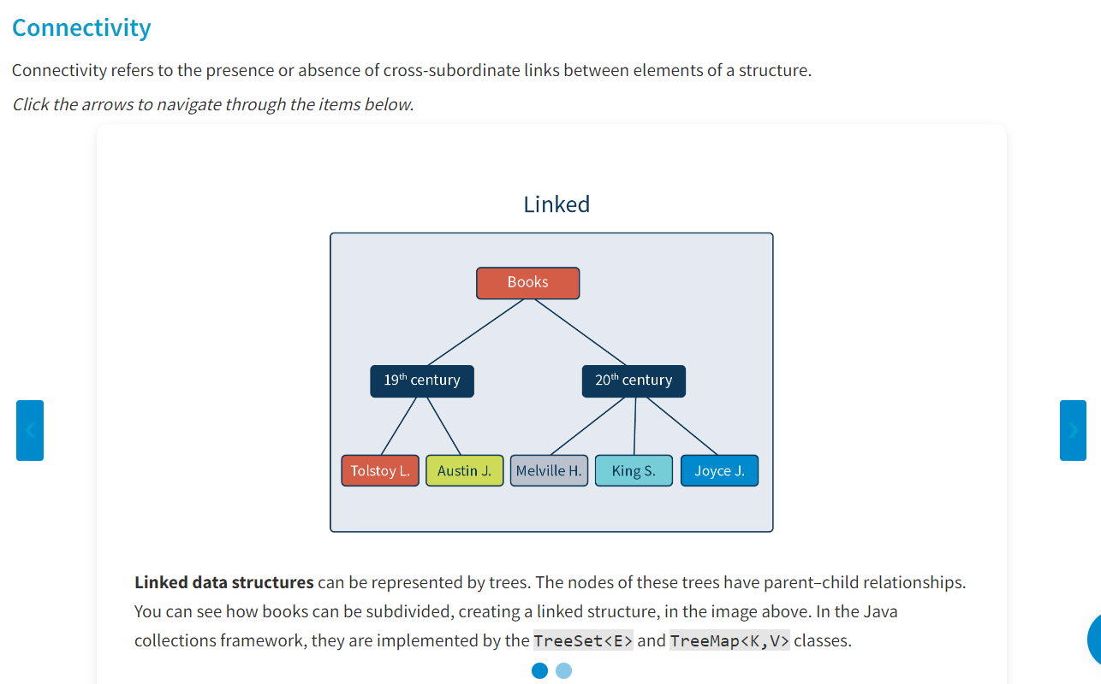

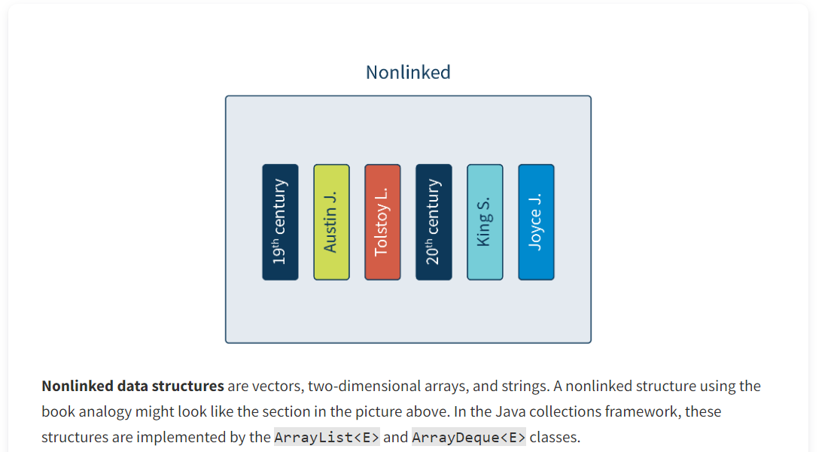

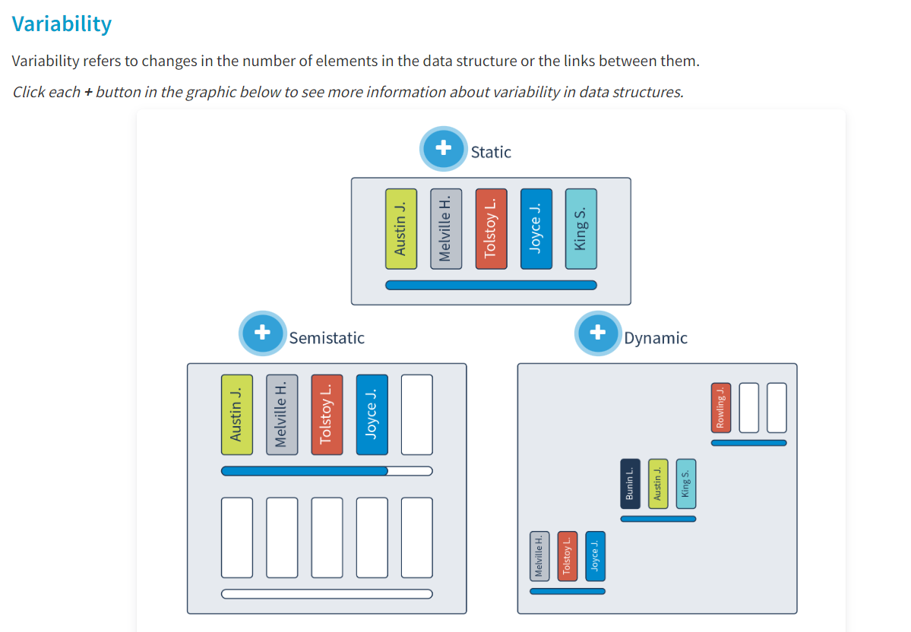

**Static**

The memory volume for **static data structures** is stable and defined at the compilation level or program execution. If the elements are books on a shelf, the size of the shelf does not change, and we can put books on it until it is filled. An example of static data structures can be a vector presented with a one-dimensional array. This type of data structure cannot be implemented in the Java collections framework.

**Semistatic**

**Semistatic data structures** vary in length. The length is changed in a certain frame that does not exceed a maximum value. The bookshelf in the image below can be extended, and you can add bookshelves to make a bookcase. However, its size is limited. Some examples of semistatic data structures are stacks and queues. In the Java collections framework, these are presented by the ArrayList<E> and ArrayDeque<E> classes.

**Dynamic**

The size of**dynamic data structures** is not stable, so memory for each element is allocated at the moment of creation, during program execution. Once an element of a data structure is no longer being used, the memory is freed up. In this case, bookshelves can be added as needed and arbitrarily placed and removed.

Additionally, several specific qualities of dynamic linked data structures must be mentioned:

* The elements of these data structures are not placed in memory sequentially, or even in the same memory area.
* The element address cannot be calculated by the initial or previous element address.
* The link between the elements is set via the references to the element addresses in the memory.

An example of implementing such data structures in the Java collections framework can be trees—the TreeMap<K,V> class, and a linked list—the LinkedList<E> class.

**Operations on Data Structures**

A range of operations can be performed on data structures. Some of them are performed with the whole data structure, and some with only one element of the data structure. The following are some operations on data structures:

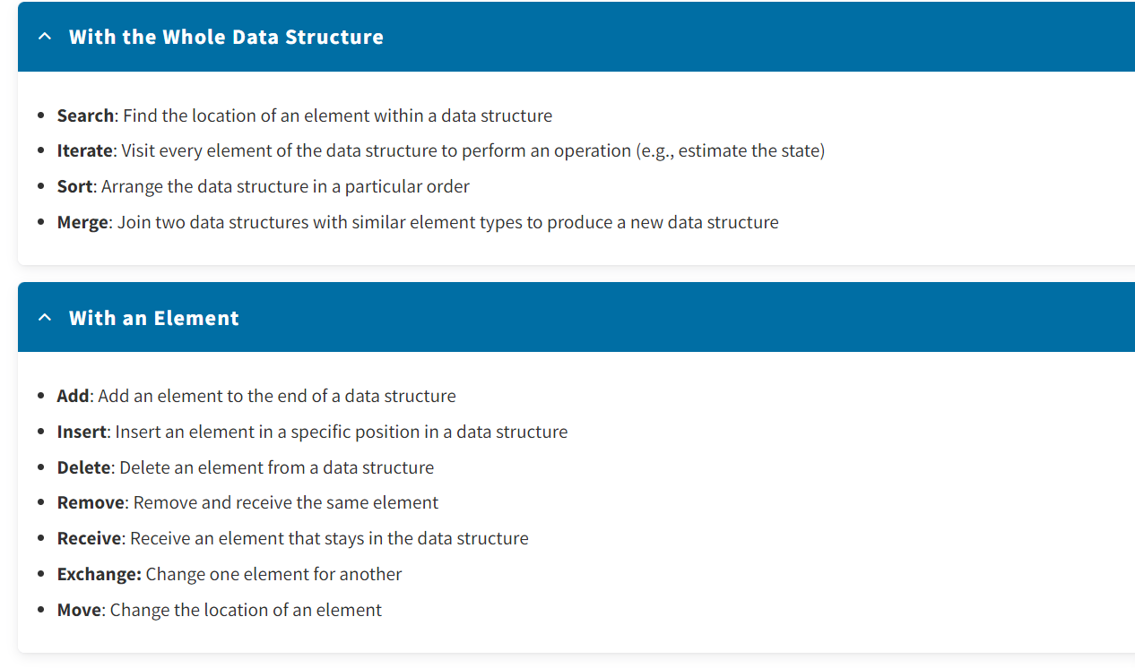

**Conclusion**

To summarize, data structures are ways of organizing information for easier access and processing. Knowing the features of data structures allows you to choose the right one and manipulate it successfully. Also, if you can define data structures, you can create new structures to suit the programming task.

* Lists :
* **Introduction**
* Digital data is stored in different forms. Lists are one of these forms and are very widespread in software. For example, developers allow users to look through and filter information to make it easier for them to find what they need—just a couple of clicks in a streaming platform app, and your favorite show is on the screen. This lesson introduces you to how lists are handled in Java Collections. You will review the List<E> and ListIterator<E> interfaces, their methods, and how they are implemented in the ArrayList<E> and LinkedList<E> classes.
* **What Are Lists?**
* Among the variety of data structures, a list is the one that provides a way of storing an ordered collection. Lists are a representation of a linear data structure with specific features for organizing and storing elements.

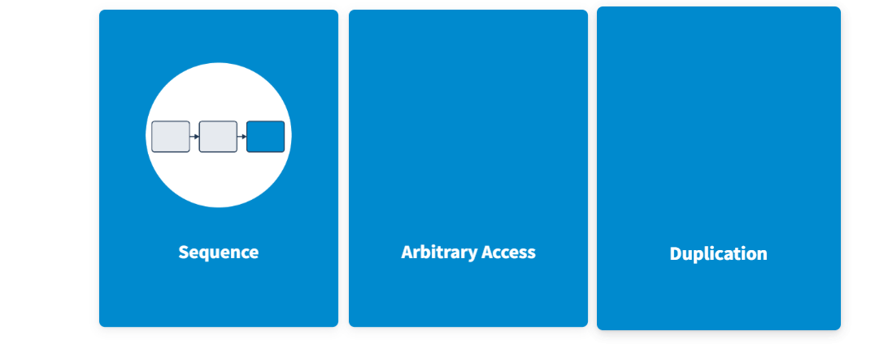

In lists, elements are placed sequentially, one by one.

Access to elements in lists may be in arbitrary order.

In lists, elements can include the values' duplicates.

These features are also implemented in lists in Java. To work with lists in Java, you can use a range of interfaces and classes

**Interfaces and Classes for Implementing Lists**

The collections framework involves several interfaces and classes that can present lists. Interfaces describe the behavior of lists, and classes implement them.

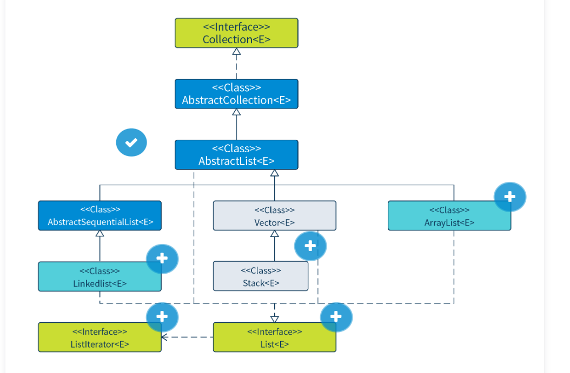

**Classes AbstractCollection<E>, AbstractList<E>, and AbstractSequentialList<E>**

These classes provide a skeletal implementation of the corresponding interfaces to minimize the effort required to implement them.

**Class LinkedList<E>**

This class is an implementation of the List<E> interface. It is a linked list built on nodes and forming chains of elements.

**Interface ListIterator<E>**

This interface is used to iterate lists both forward and backward.

**Classes Vector<E> and Stack<E>**

These are legacy classes that were deprecated starting with Java 5.

**Interface List<E>**

The List<E> interface describes the behavior of data structures such as lists.

**Class ArrayList<E>**

This class is an implementation of the List<E> interface. It is a list built on a resizable array.

In the next section, you will have a closer look at the methods of the List<E> and ListIterator<E> interfaces and its implementation in the LinkedList<E> and ArrayList<E> classes.

**The Interface List<E> and ListIterator<E> Methods**

Interface List<E> signifies arbitrary access to list elements through their indexes and sequential access through the ListIterator<E>.

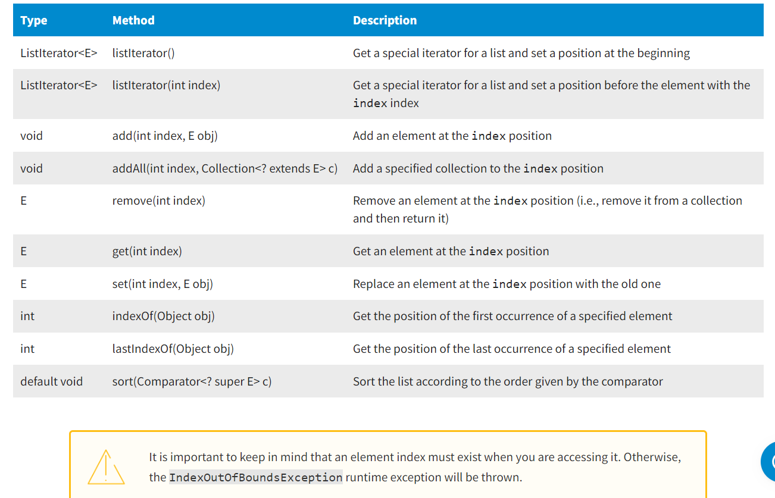

The ListIterator<E> interface extends the Iterator<E> interface and is designed to process lists in different ways, The ListIterator<E> interface also allows you to access the list element at any position, for example, by calling the listIterator() method.

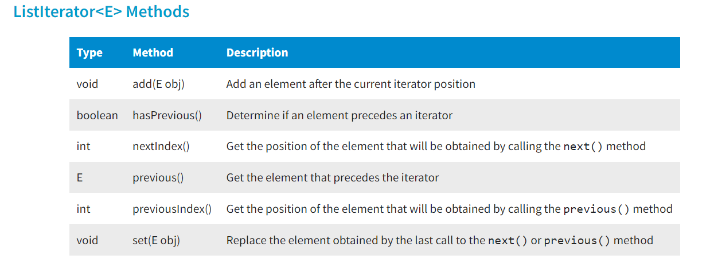

**Approaches to Processing Lists**

The behavior defined by the Collection<E>, Iterator<E>, List<E>, and ListIterator<E> interfaces involves two approaches to handling list elements: **sequential** and **arbitrary**.

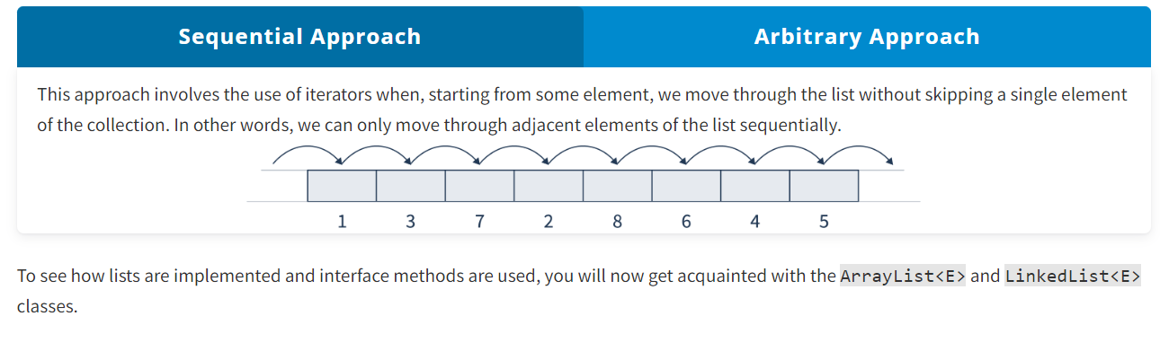

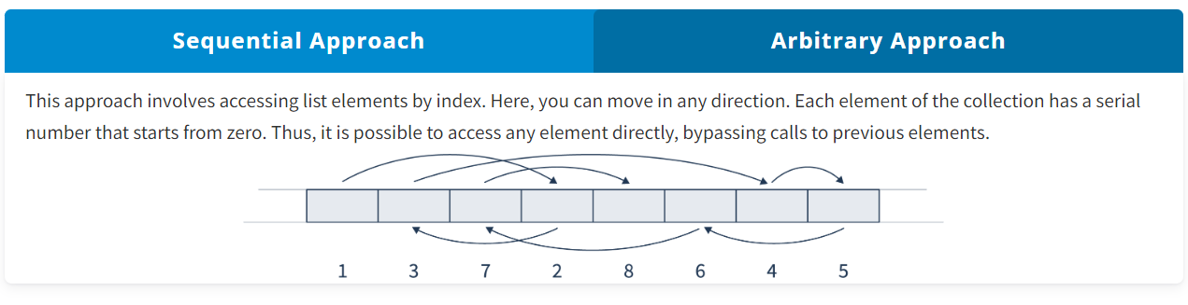

**Class ArrayList<E>**

The ArrayList<E> class is an implementation of the List<E> interface. It is an array-based list that can change its size during program execution. In other words, it is a resizable array that offers constant, real-time positional access and is very fast. ArrayList<E>'s behavior prompts the following features of its data structure: It is ordered, homogeneous, linear, nonlinked, and semi-static. Also, the ArrayList<E> class does not need to allocate memory for each element separately. It can take advantage of the Arrays.copyOf() method when it needs to move multiple elements at the same time.

The ArrayList<E> class organizes work in a special way. To understand how it functions, take a look at the processes behind the code.

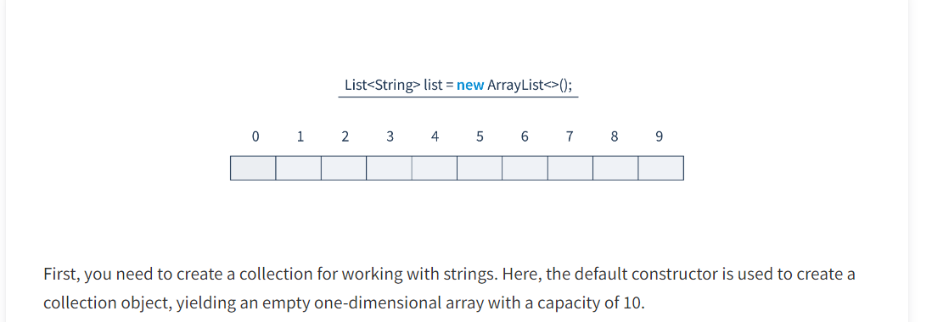

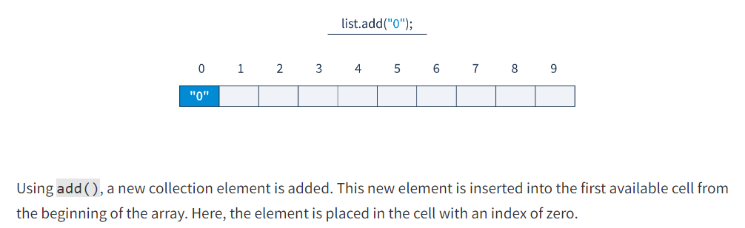

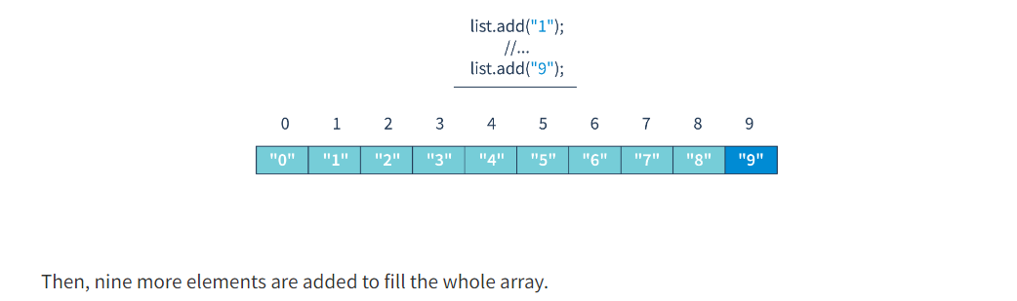

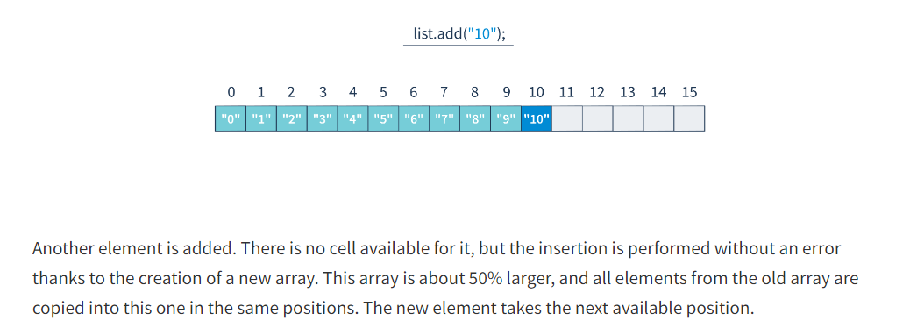

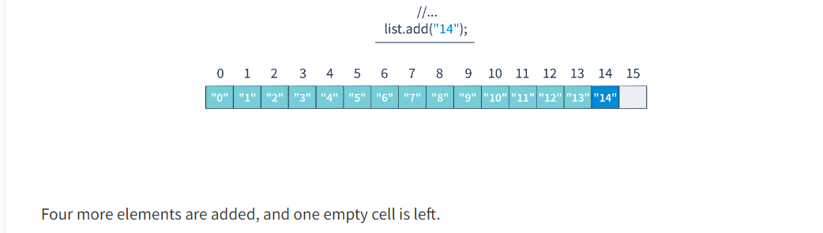

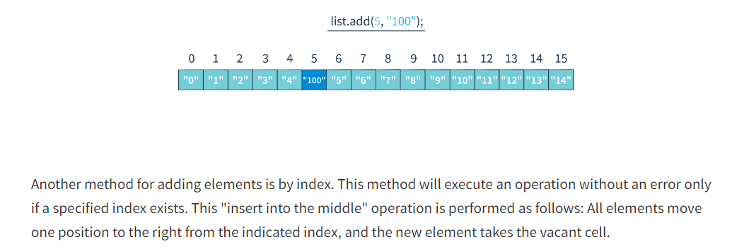

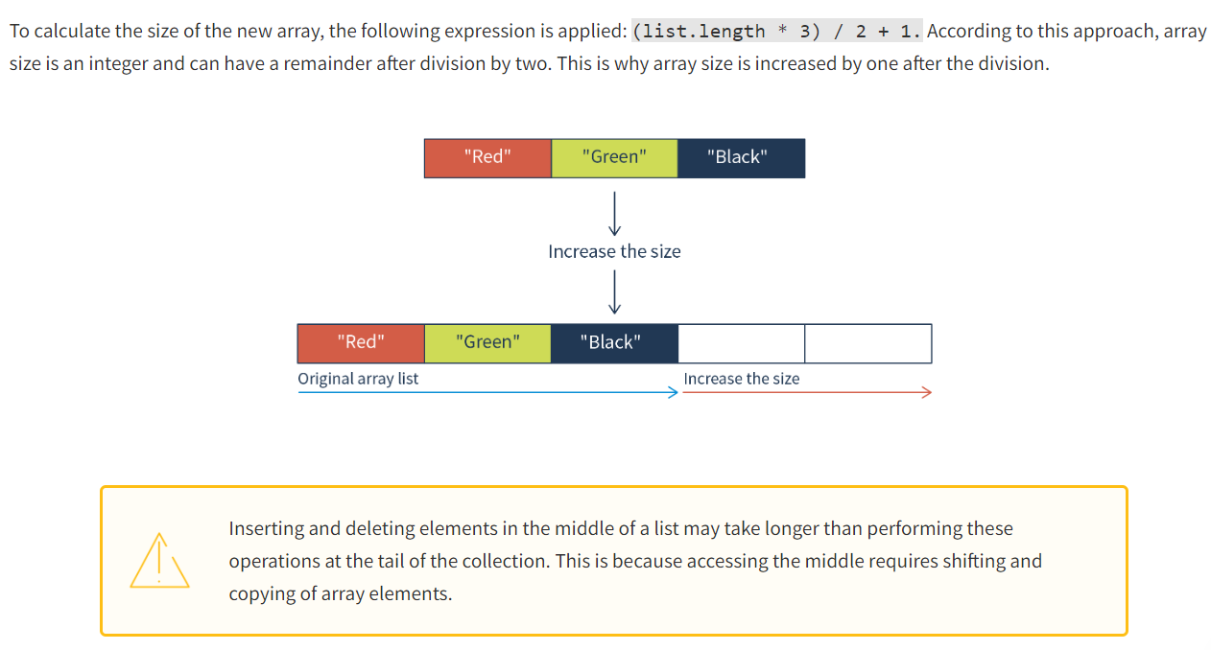

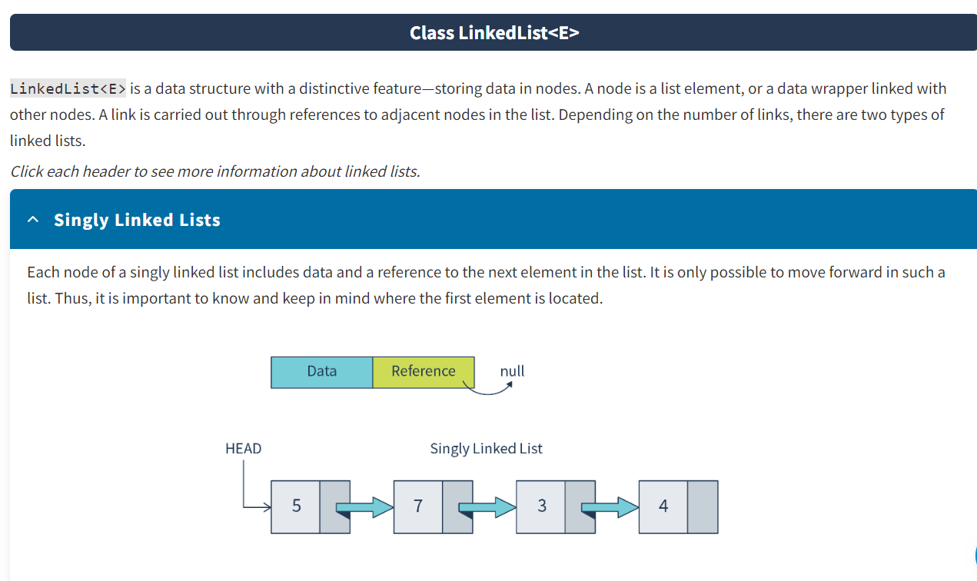

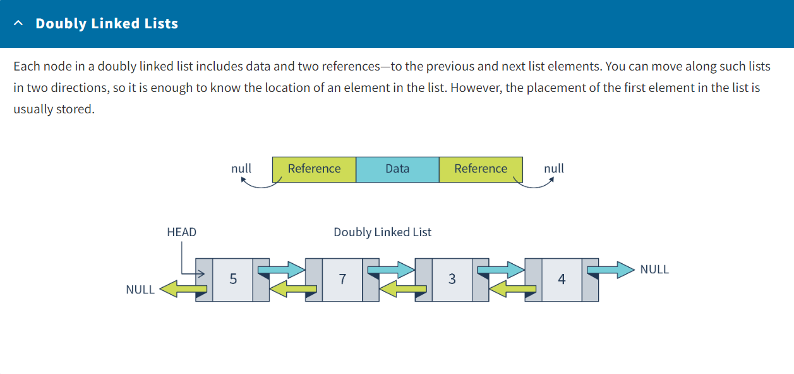

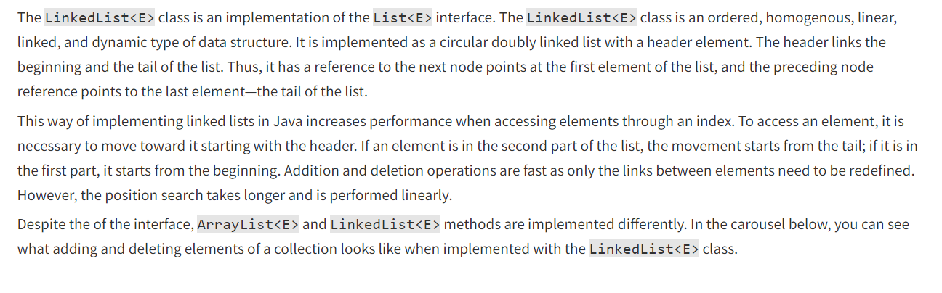

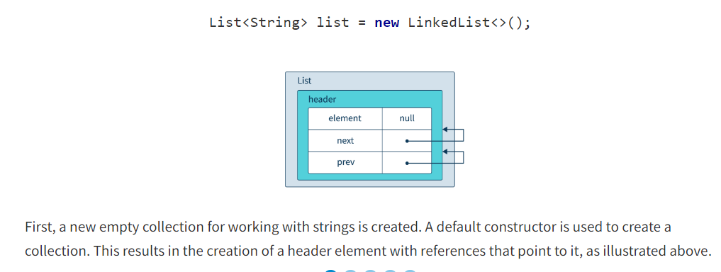

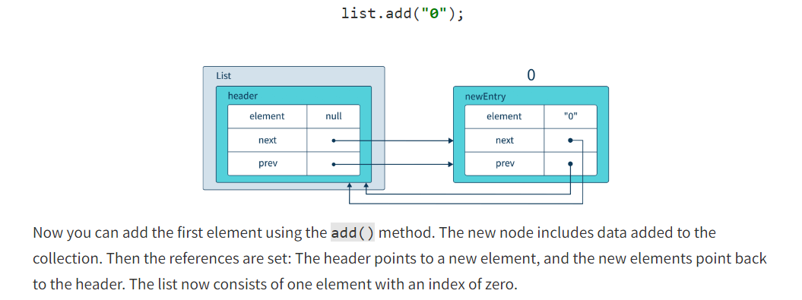

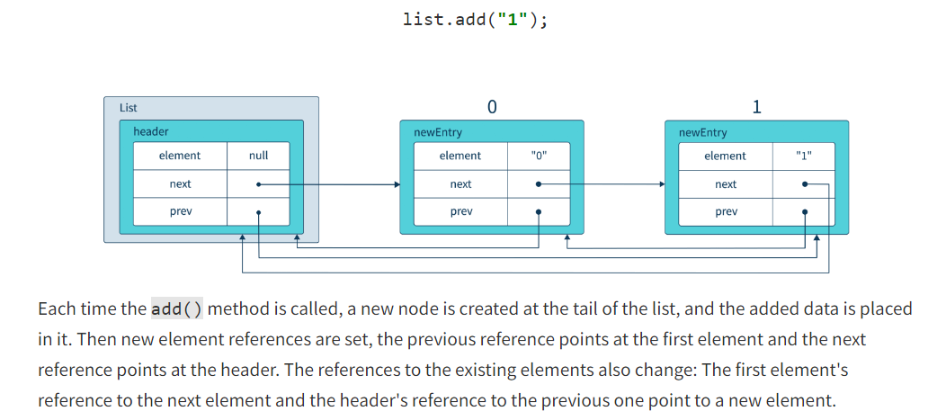

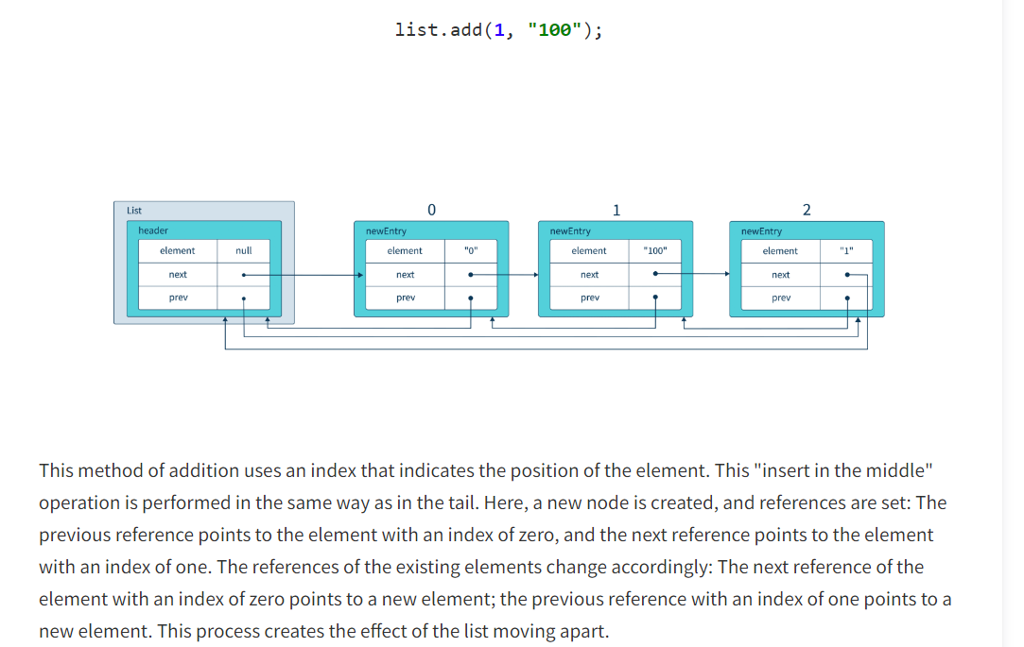

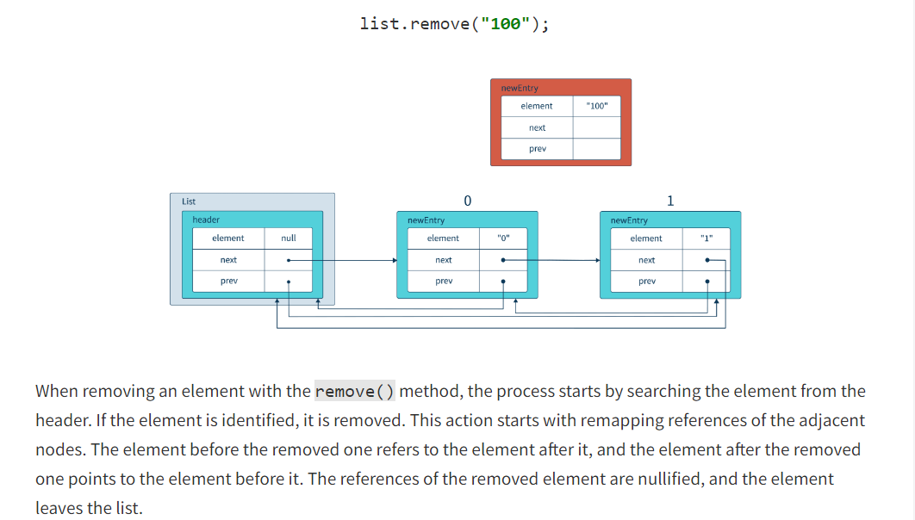

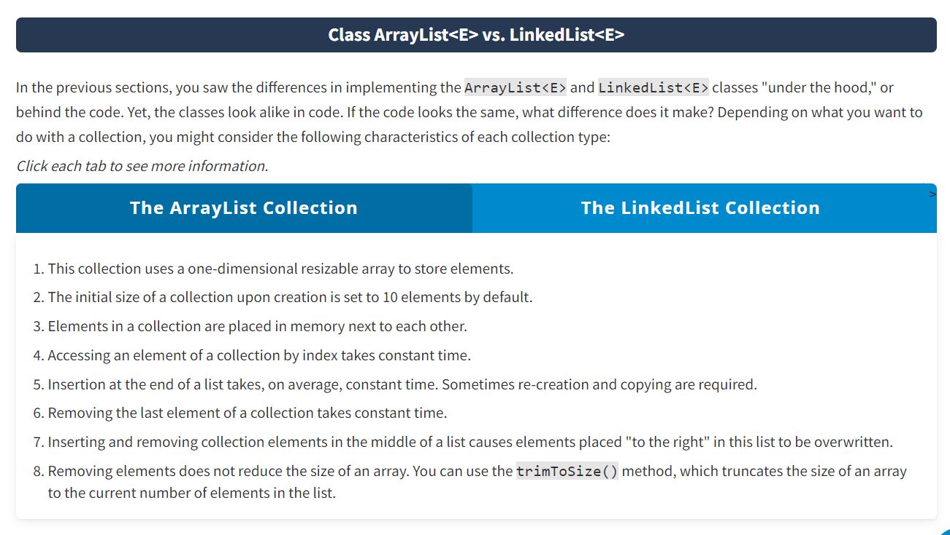

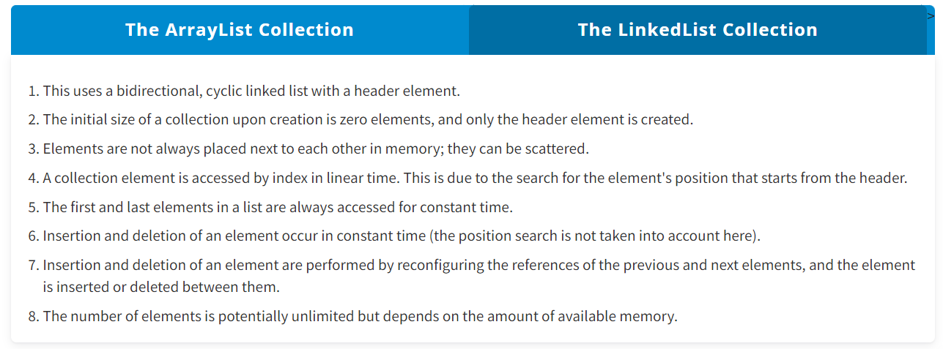

Queues :

**What Is a Queue?**

In programming, a queue is similar to a line in the real world. If you are first in line at the counter to buy a movie ticket, you will be the first one to get your ticket. The queue data structure works according to the same principle.

A **queue** is a linear ordered data structure with inherent characteristics that define how to process its elements

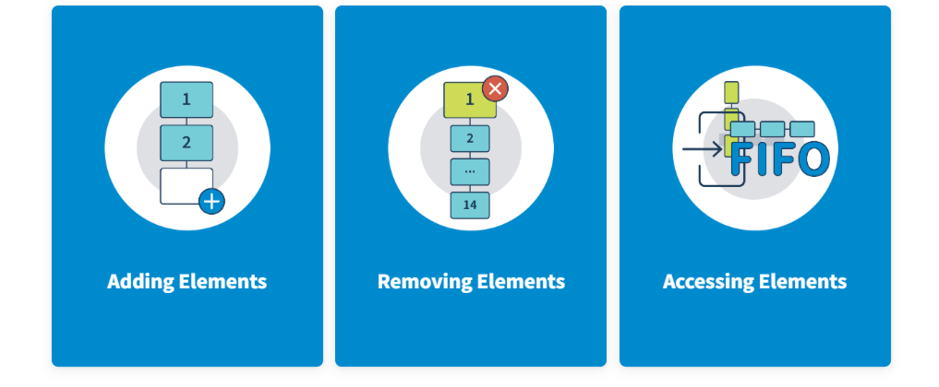

You can add elements only to the end—aka tail—of a queue.

You can remove elements (delete and return) only from the head—aka front—of a queue.

You can access elements according to the first-in, first-out (FIFO) rule.

So, queues are designed to hold elements before they can be processed. It works just like a line for movie tickets: You cannot go straight to the counter if other people are in front of you. Once it is your turn, you get the ticket and leave.

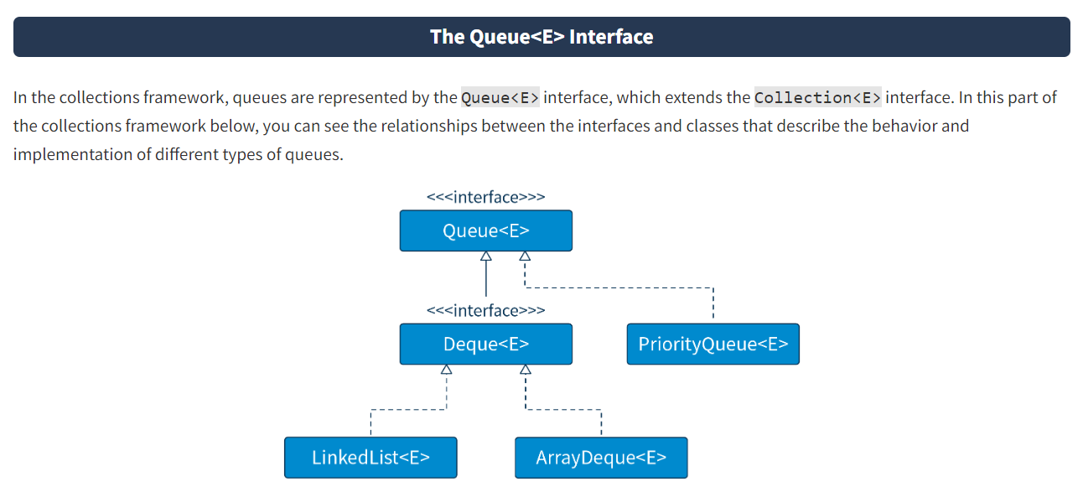

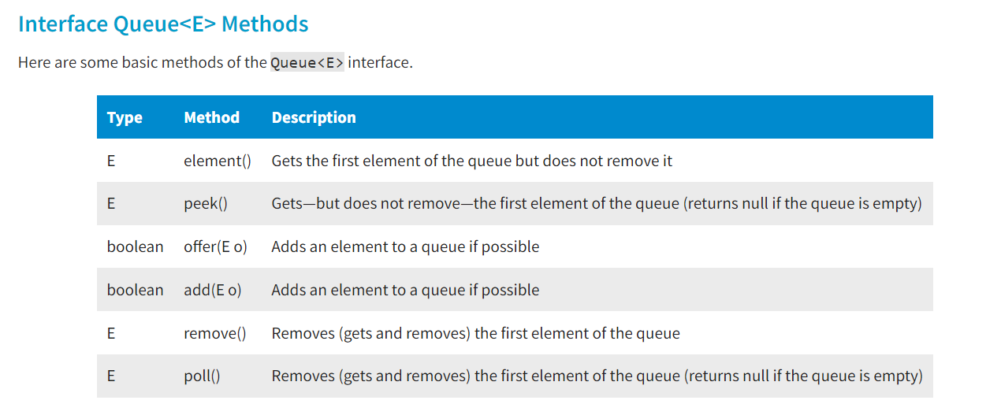

Note that the element(), remove(), and add() methods throw an exception if they cannot perform their actions.

The peek(), poll(), and offer() methods are intended to be used when a failure is normal behavior, not an exception—for example, in queues with a fixed capacity.

Thanks to the interface's queue features, each method works with boundary elements of a collection. The FIFO principle defines the behavior of these methods

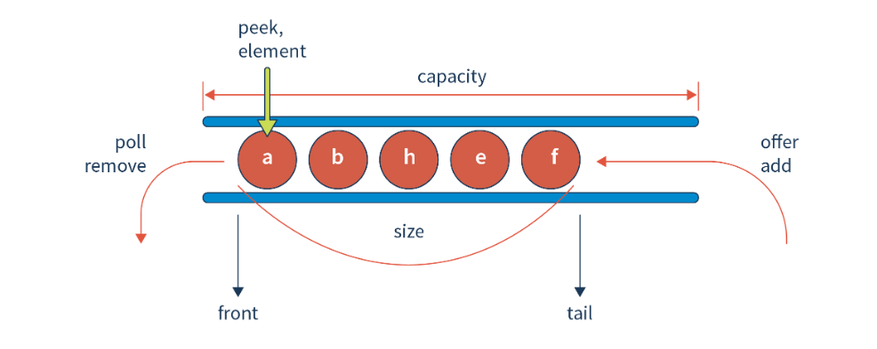

#### Using Queue<E> Methods

The following example demonstrates the work of the remove(), offer(), and poll() methods.

Now, follow the code lines to see how the program is implemented. An empty list is created and parameterized by the Number type, which is accessed using a reference to the List interface. Then, six objects of the Integer type and five objects of the Float type are added to it, and the list is displayed. This is a list with random access to elements, but you can assign queue properties to list. To do this, the que reference of the Queue type is created, parameterized by the Number type, and initialized with the value of the list reference.

Before assigning the reference, you should cast the list reference to LinkedList because the Queue and List interfaces are in different inheritance branches and their references cannot be assigned to each other directly. However, the LinkedList class implements both interfaces, which means that an object of the LinkedList type can be called to both of them. It is a bit like looking at the same object from different angles. Now you can work with the list as a queue.

Next, you can see the work of the method remove(), which removes the first element, offer()—which adds a new element at the tail—and poll(), which deletes the first element. This queue also calls the remove() method with an argument that searches for the element with the specified value and, if it exists, removes it. There is no element with the value 1, so deletion does not occur. At the end of the example, a for-each loop is used to display the contents of the list.

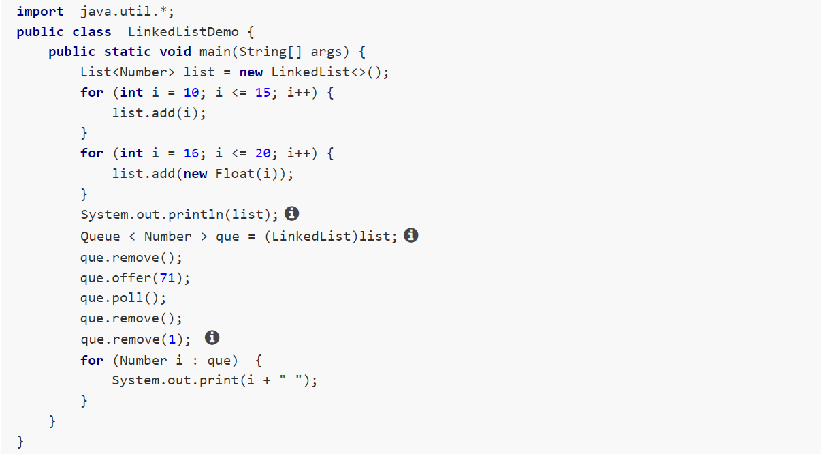

**Class PriorityQueue<E>**

A **priority queue** is similar to a regular queue, but each element is assigned a "priority": A high-priority element is served before a low-priority element. Depending on which constructor is used, the items in the priority queue are ordered according to their natural ordering or by a comparator provided when the queue is constructed.

Where is a priority queue used? For example, an order processing queue may contain orders of various importance. More important orders need to be processed as soon as possible, even if they arrived later than others. Such orders are moved to the front of the queue and processed first.

**Interface Deque<E>**

Another interface describing queues is Deque<E>. The Deque<E> interface extends the Queue<E> interface and represents the behavior of a linear data structure—a bidirectional queue. This means that it is possible to work with this data structure both as a queue and as a stack.

In a **stack**, access to elements is defined by the **LIFO** rule—last-in, first-out. Here, the new element is inserted above and pushes the previous element down so that the new element is at the top and can be removed first. Therefore, the first element pushed on the stack comes out last, as shown in the image below.

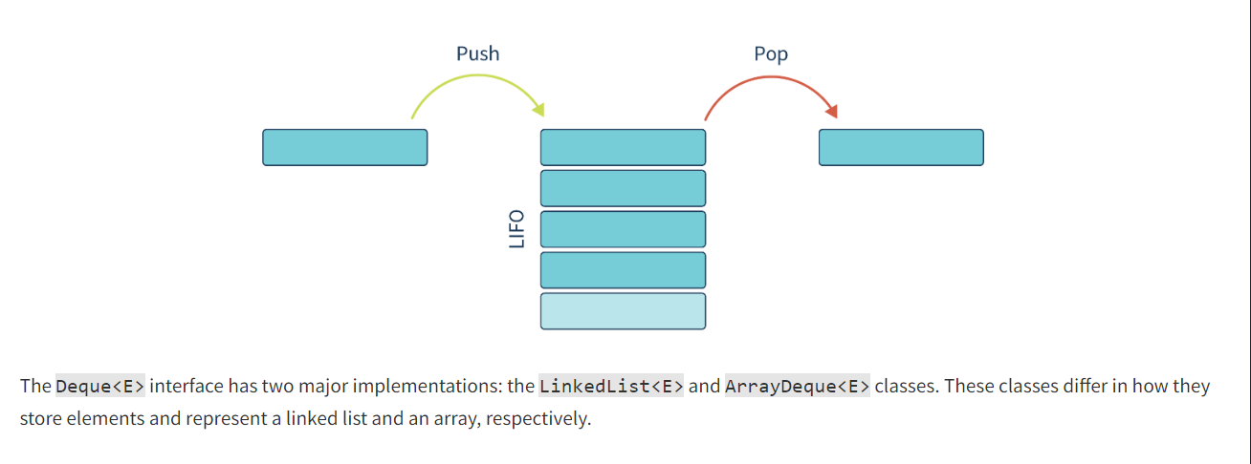

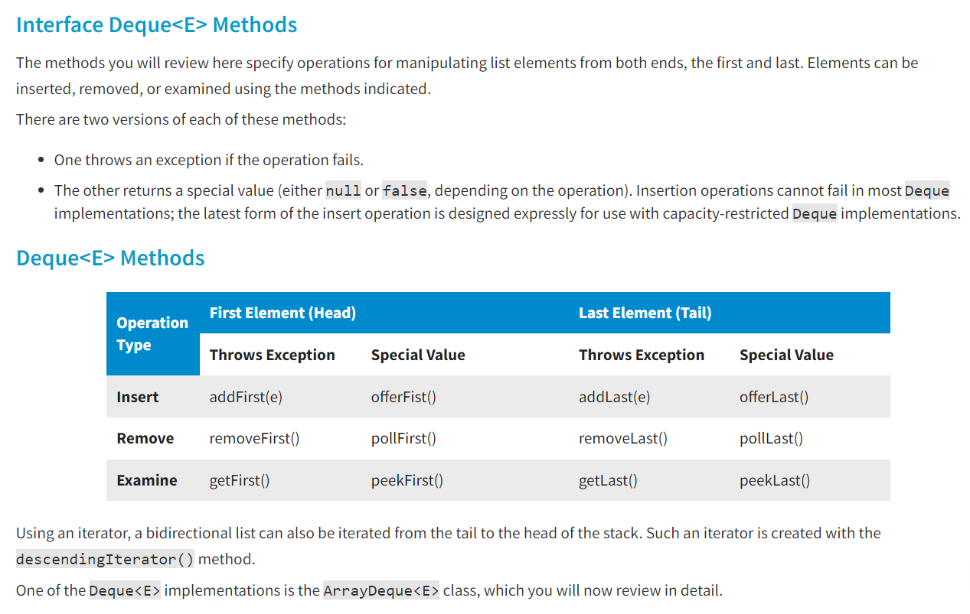

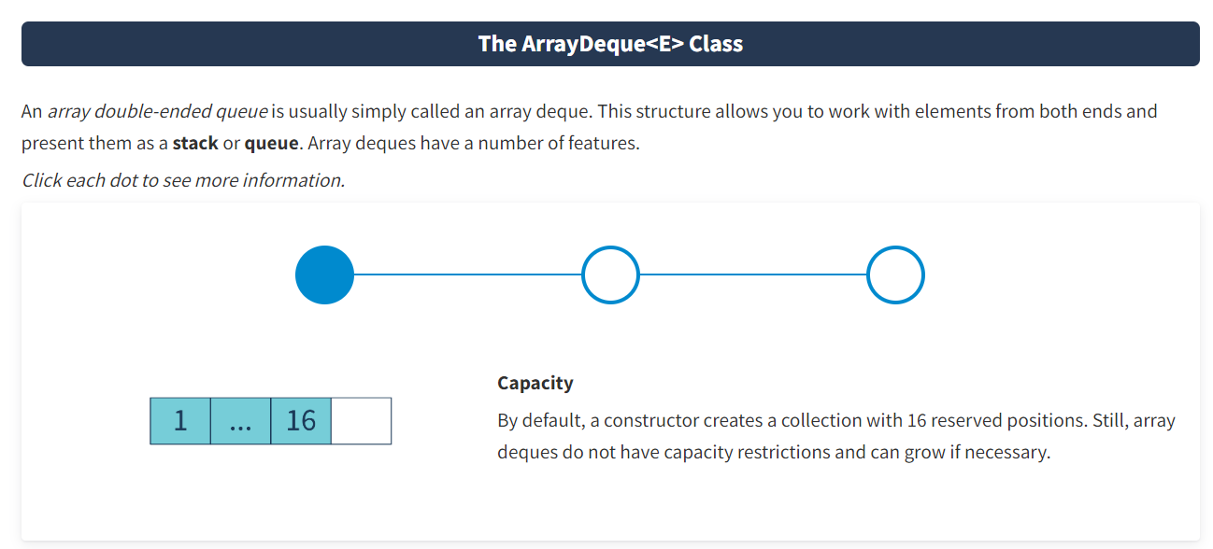

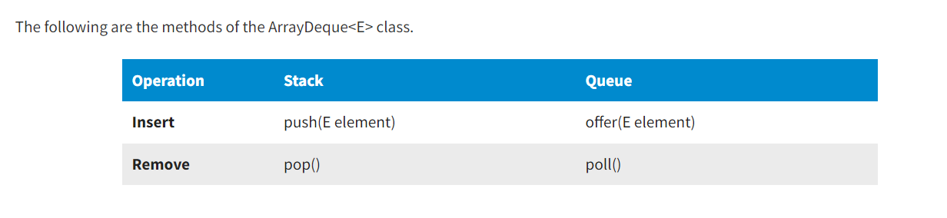

**Conclusion**

To sum up, queues are made to hold elements before processing them. You can operate such collections by adding, removing, or accessing elements in a specific manner, depending on the type of queue. The Queue<E> interface describes queues and uses the FIFO method to process elements. An implementation of the interface is the PriorityQueue<E> class. The Deque<E> interface is a bidirectional queue that can be manipulated as a queue or a stack. Stacks follow the LIFO rule. Interface implementations include LinkedList<E> and ArrayDeque<E>.

* Sets :
* **Introduction**
* Hashing everywhere in technology nowadays: in cybersecurity, cryptocurrency, data encryption, etc. Java also supports hashing and uses hash tables. In this lesson, you will become familiar with set data structure, hashing, and hash tables, including how they are implemented in Java.
* **A Set As a Data Structure**
* A range of Java implementations such as hash sets, tree sets, and linked hash sets represent set data structure. The notion of a set is a mathematical concept and represents a collection of unique elements. This means that **sets do not allow duplicates**. This feature defines how a collection behaves, which you will see in the examples with hash tables in this lesson.

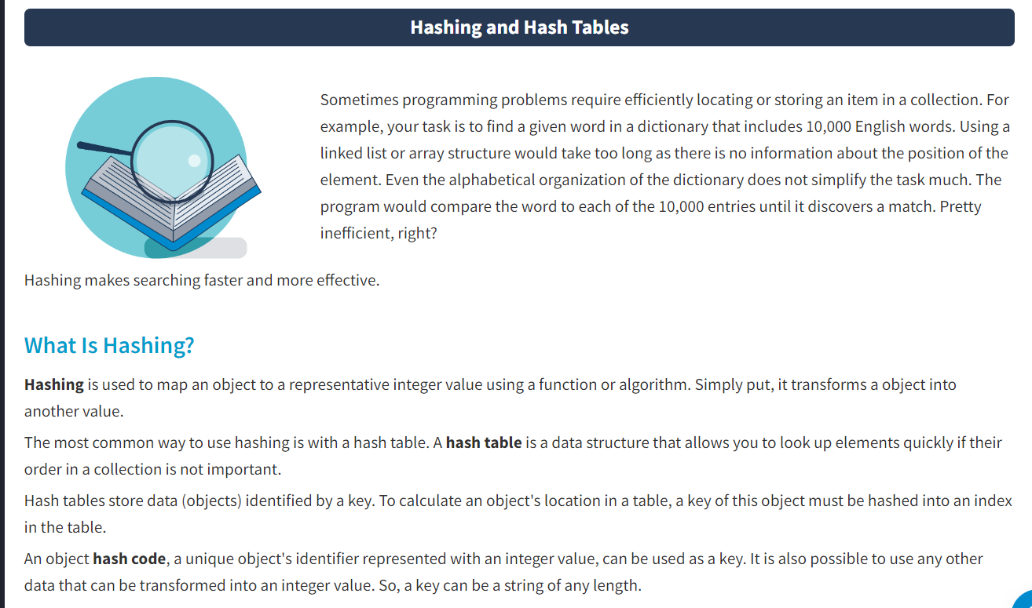

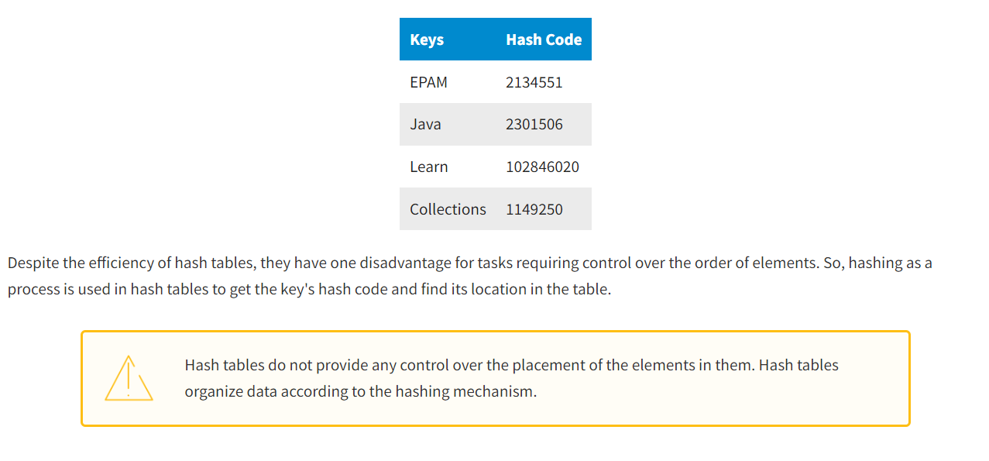

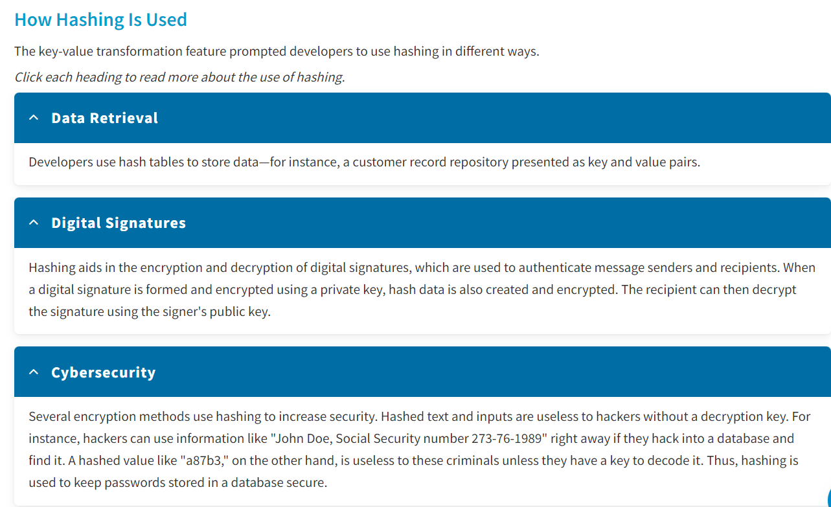

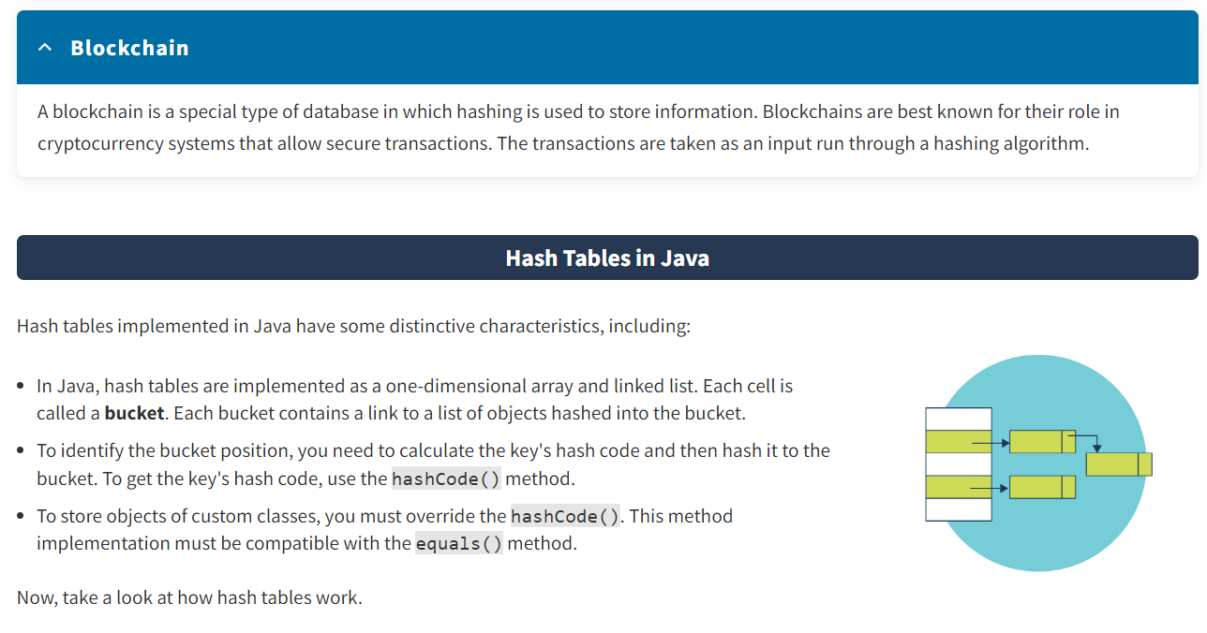

**Hash Tables in Action**

The **division modulo** operation is used to locate an object in a table. In this method, the hash code is divided by the number of buckets and yields a remainder, which will be the bucket index, or the cell index in a one-dimensional array. The formula looks like this:

index = hash % num_buckets

For example, an object has a hash code of 2134551, and there are 128 buckets in the hash table. Applying the formula, you get the equation**2134551 % 128 = 23.**Therefore, 23 (the division remainder) is the bucket index where the object is stored. If there are no elements in the bucket, the object is placed in this bucket and becomes its first element. Thus, the bucket is a singly linked list.

If the bucket already contains elements, a hash table **collision** takes place. The inserted object is compared with all the objects in the bucket to see if it is already there. Thus, with a relatively even distribution of hash codes and a sufficiently large number of buckets, only a few comparisons are needed to find the desired element.

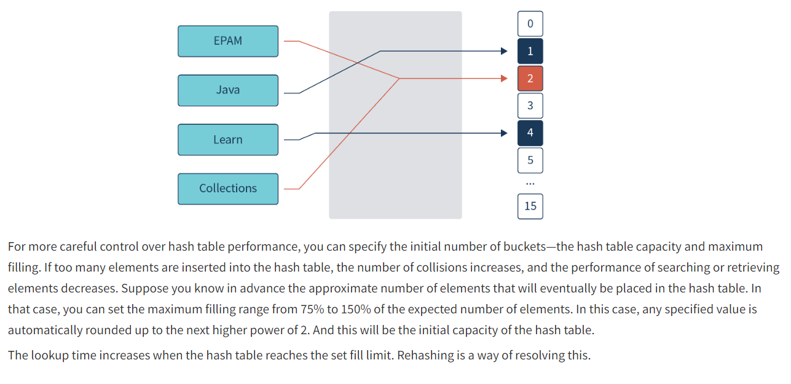

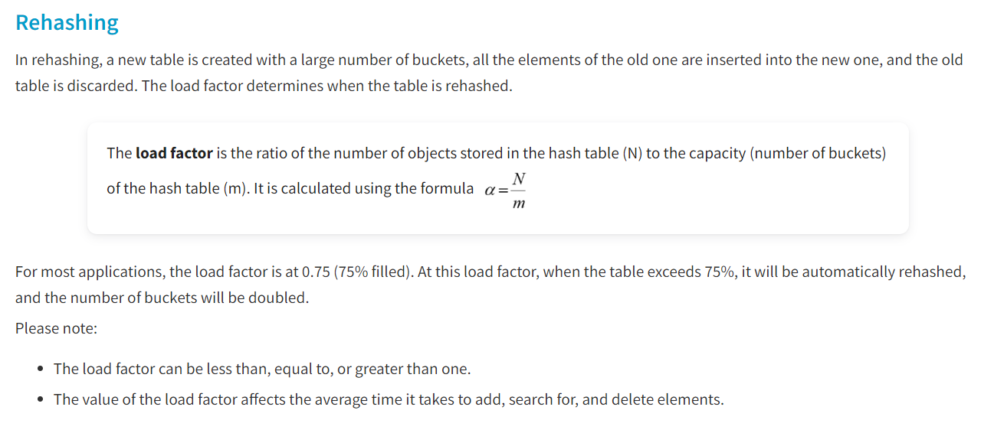

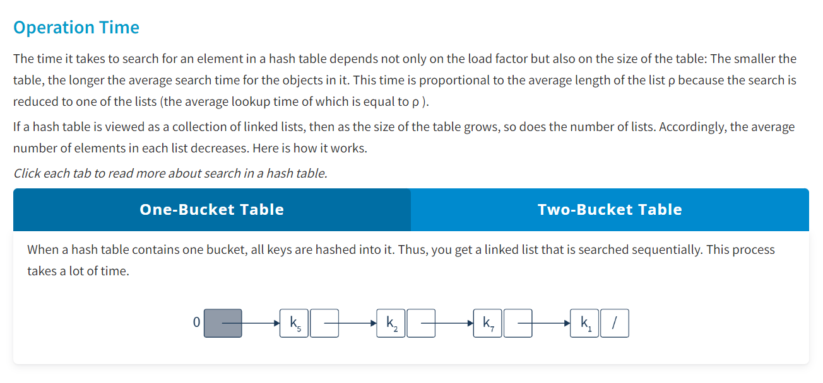

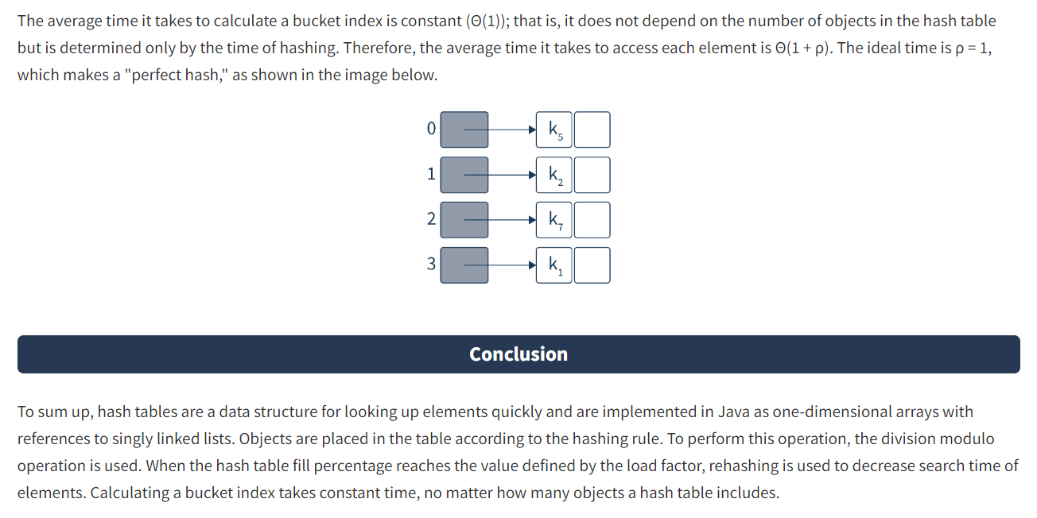

* HashSet and TreeSet :

**Introduction**

The notion of a set was borrowed from mathematics and translated into different programming languages. A set's data structure has some incredibly useful functions that can solve various programming tasks. In Java, sets can be implemented in hash tables. This lesson will introduce you to the Set<E> and SortedSet<E> interfaces, the HashSet<E> and TreeSet<E> classes, and some features of operations with sets.

**What Is a Set?**

When you need to quickly determine whether an object belongs to a collection of values, a data structure called a set can help you. Sets are usually used to describe a dataset of unique objects for which fast search operations are important.

A **set** is a data type that can hold a collection of values in any order, with no duplicates. It is a computer program that implements the mathematical idea of a finite set.

Sets are also represented in the collections framework. One of the general interfaces that represent sets is the Set<E> interface.

**The Set<E> Interface**

A set is a data structure that can be implemented as a hash table or a binary tree. In Java, a set is defined by the Set<E> interface, which has some specific features.

*Click each dot to see more information about the Set<E> interface.*

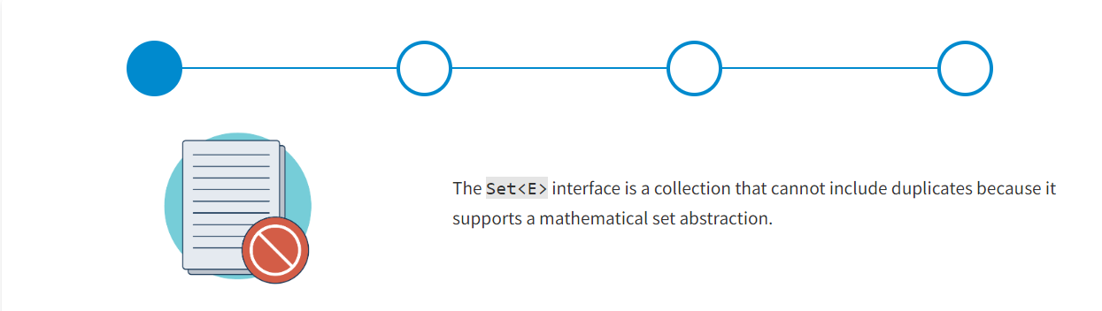

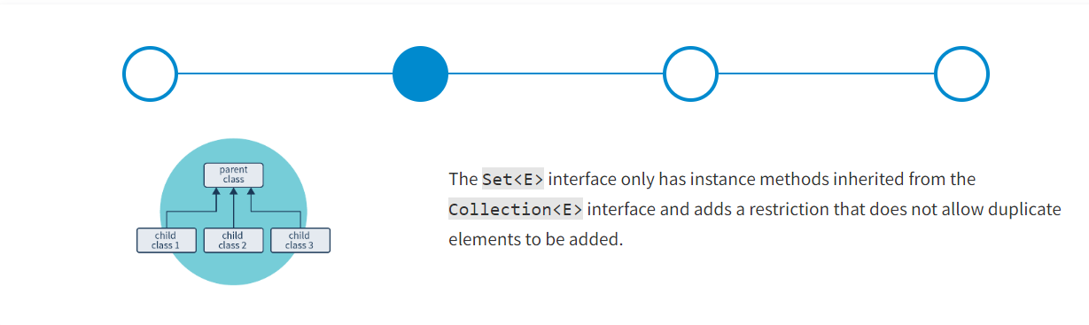

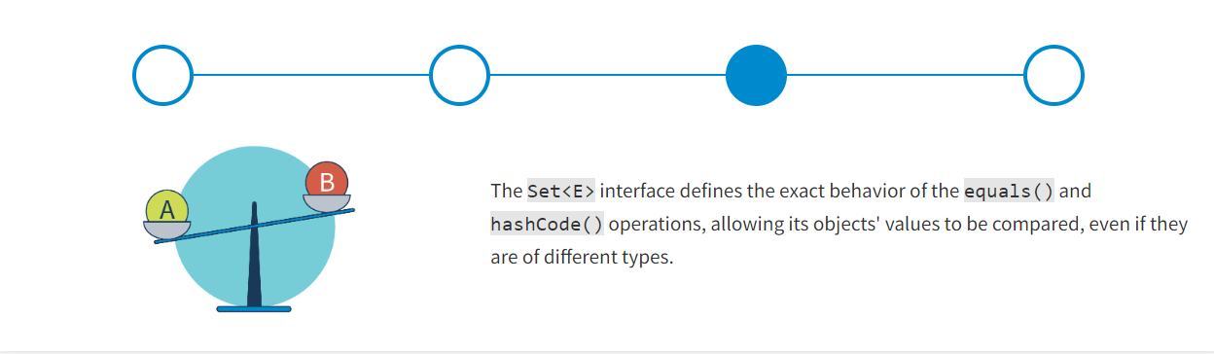

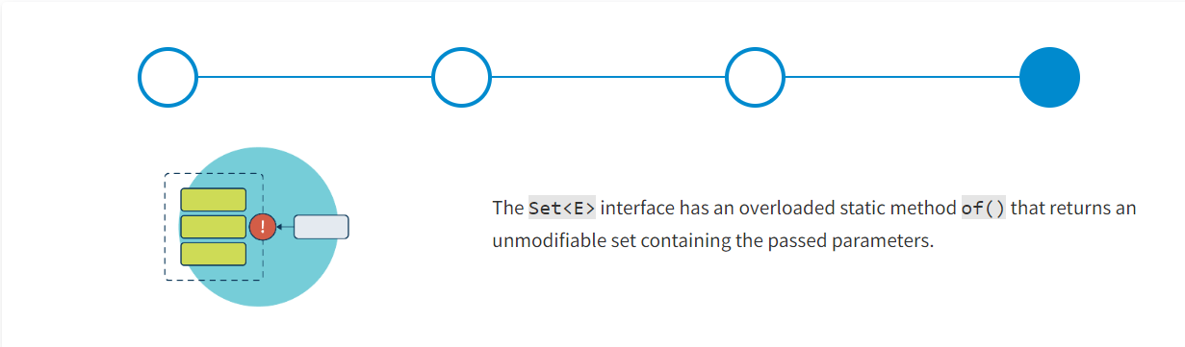

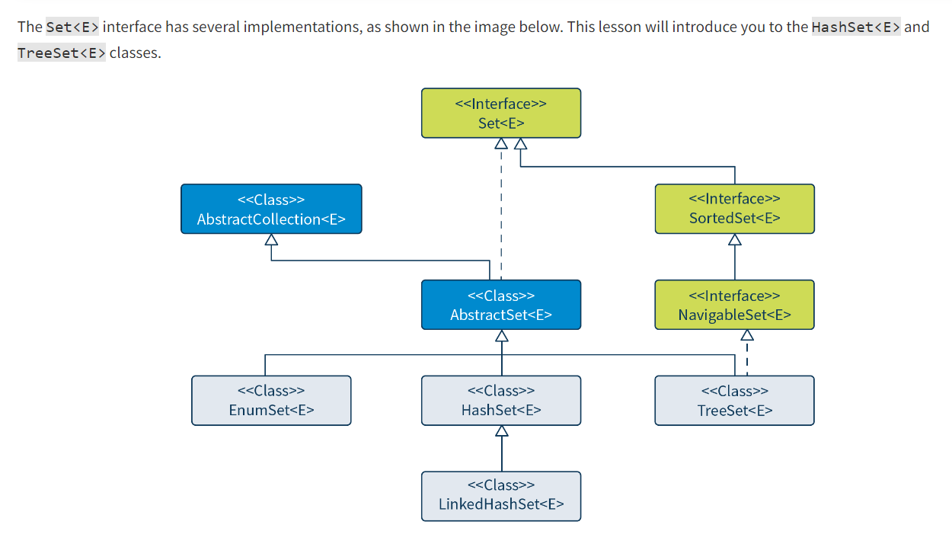

**The HashSet<E> Class**

The HashSet<E> class extends the AbstractSet<E> abstract class and implements the Set<E> interface using a hash table to store collections.

The object's key (its hash code) is used to calculate the hash table index for accessing objects in a set, which helps speed up finding, adding, and retrieving an element. The speed of these operations is especially relevant for collections with a large number of elements. HashSet<E> is not an ordered structure. These types of sets can store elements with the same hash codes if the elements are not equivalent when compared. To organize a hash set well, the implementations of the hashCode() and equals() methods must comply with the contract.

HashSet<E> has the following constructors:

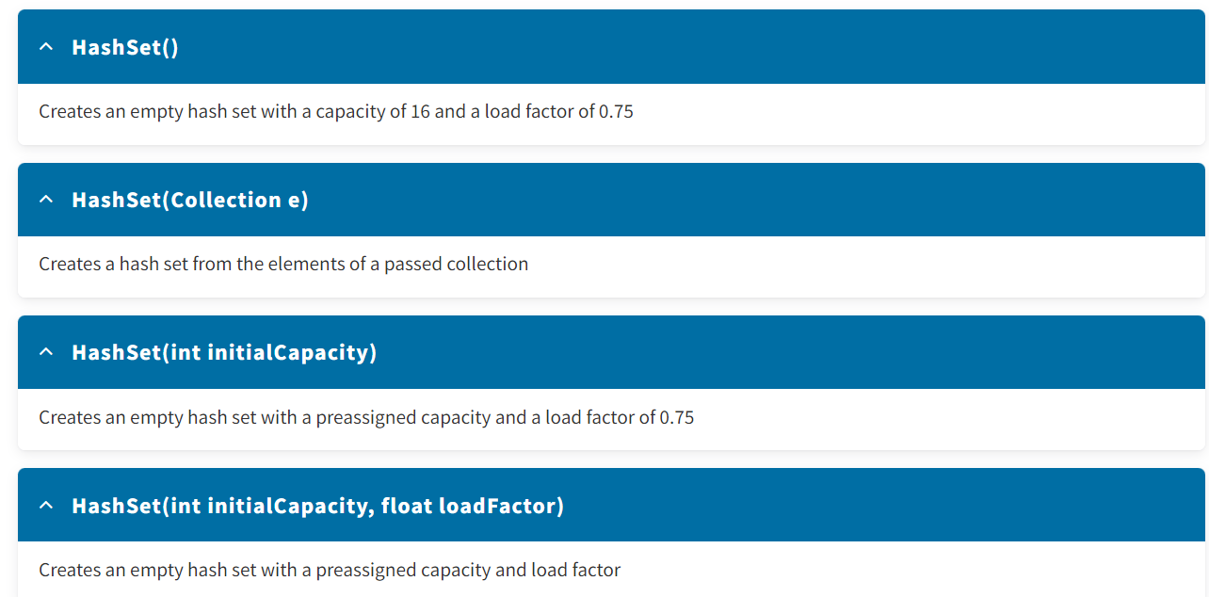

**Operation Features**

Operations on the HashSet<E> class have some distinctive features. Now you will review the addition and iteration operations.

**Adding an Element**

The algorithm for adding an element to a hash set is significantly different from those used in regular lists. The process has three main steps.

*Click each arrow to see the steps for adding a hash set element.*

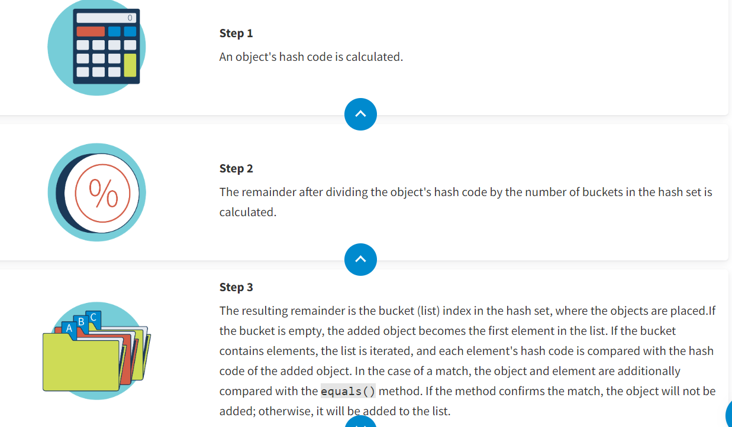

Using the equals() method is necessary since the match by hash code does not mean that the objects are equal. Also, different objects always have different hash codes, and comparing hash codes is faster than comparing objects with multiple characteristics. That is why hash codes are compared in the first place.

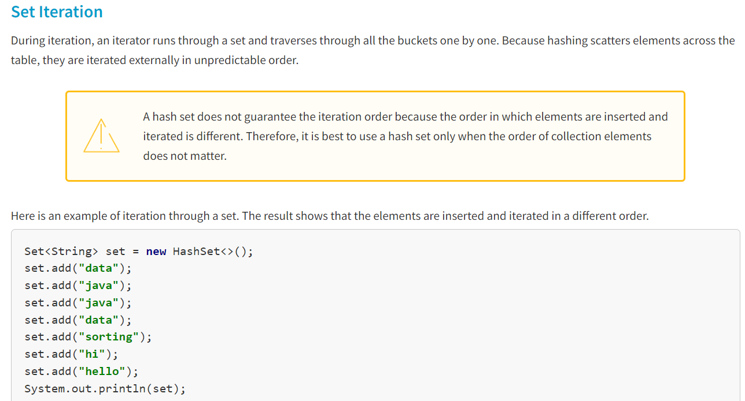

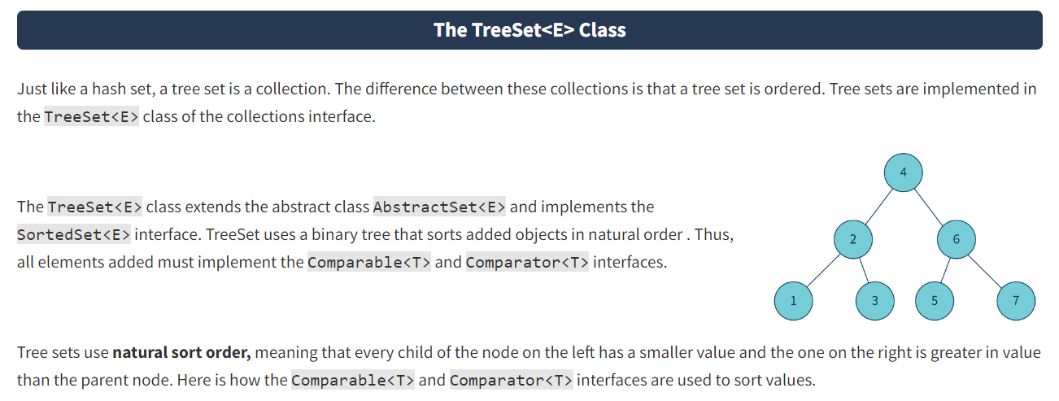

The interface defines the natural sort order. The interface is used to change the sorting order.

**Red-Black Trees**

Ordering is defined by the tree data structure, namely the binary tree. In Java, an implementation of binary tree is a red-black tree. First, you will explore what a binary tree is.

A **binary tree**is an ordered non-linear data structure where each element (node) has a connection with no more than two other nodes (children).

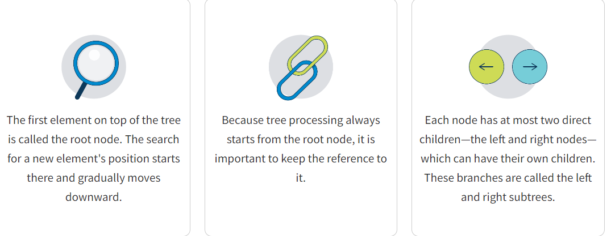

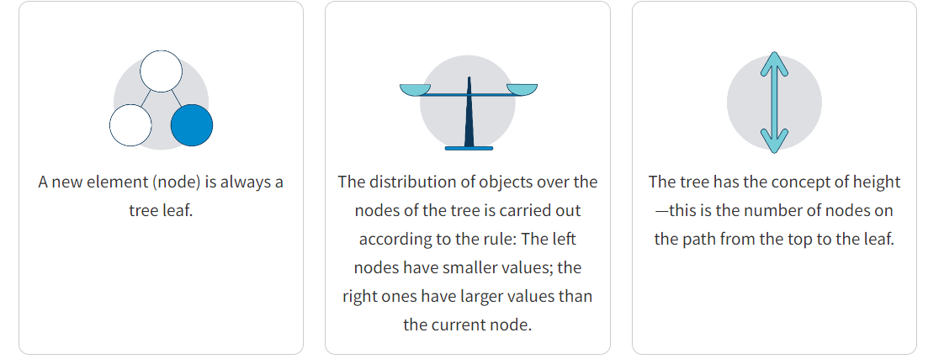

13) The root node is always black.

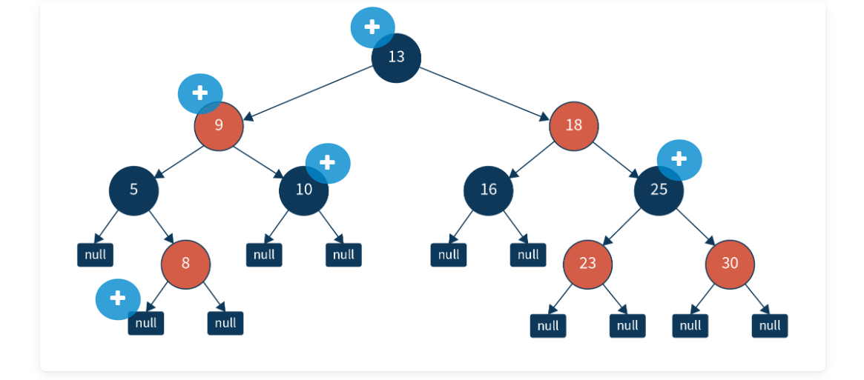

9) Every node is either red or black.

10) A red-black tree contains an equal number of black nodes on the way from the root node to any tree leaf.

Null) All final nodes (empty null nodes) are black.

25) The two child nodes of every red node are black, i.e., nodes in neighboring levels are different colors.

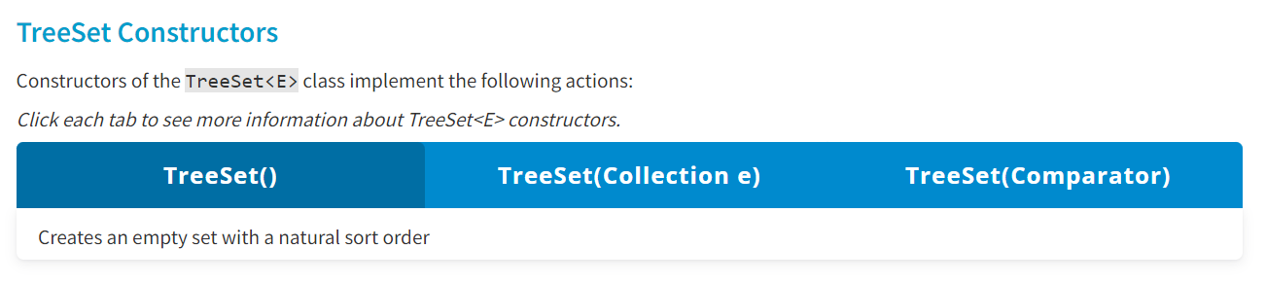

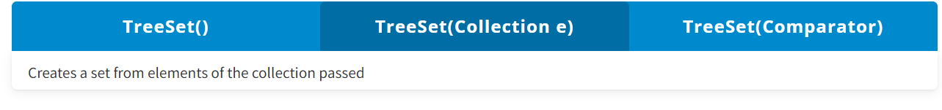

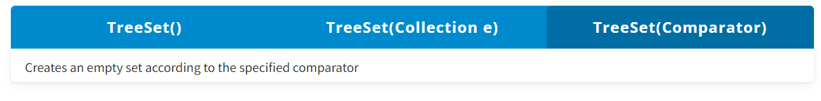

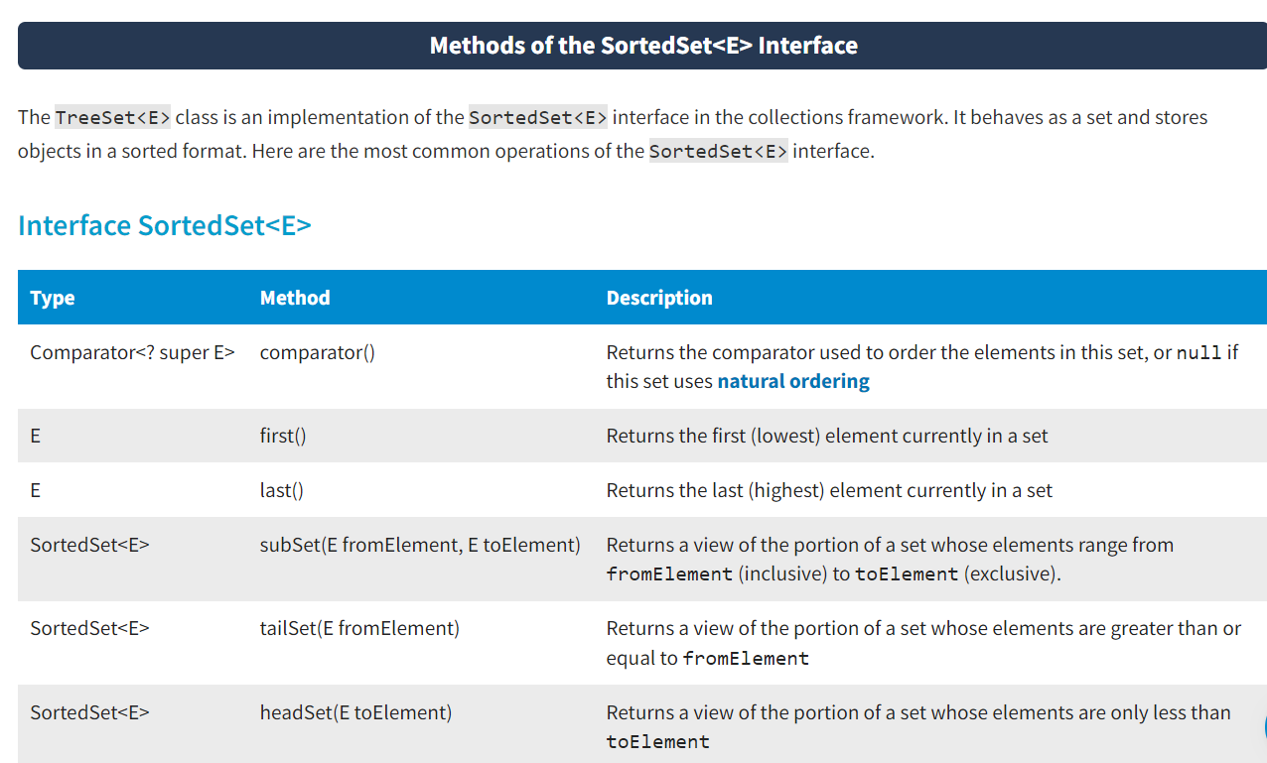

**Examples of Tree Sets**

The examples below show how to traverse through a tree set and search for specific elements in different parts of a collection.

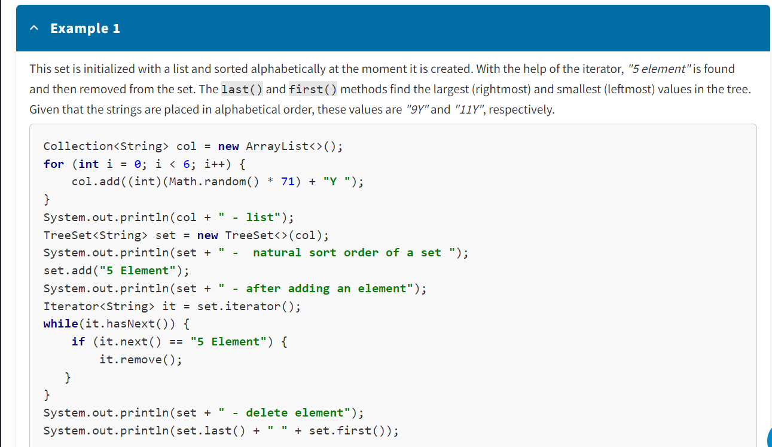

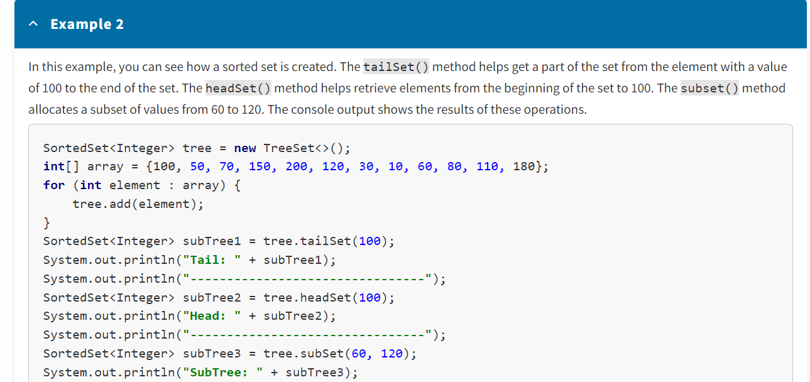

Note that it takes longer to add an element to a tree than to a hash table. Yet, addition to a tree set is faster than to an array or linked list. If a tree contains *n* elements, it usually takes *log2n* comparisons to find the correct position for a new element. For example, if a tree contains 1000 elements, adding a new one requires about 10 comparisons.

**HashSet vs. TreeSet**

The HashSet<E> and TreeSet<E> classes both implement the Set<E> interface but have some important differences.

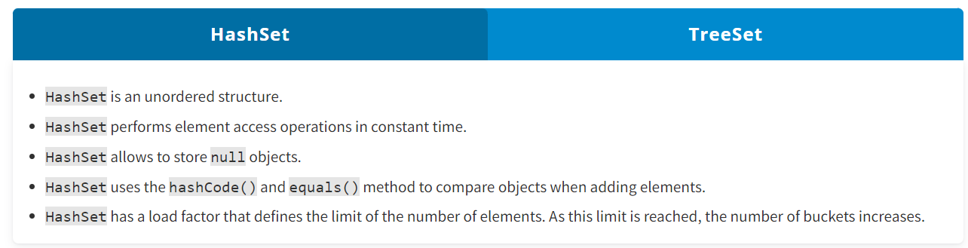

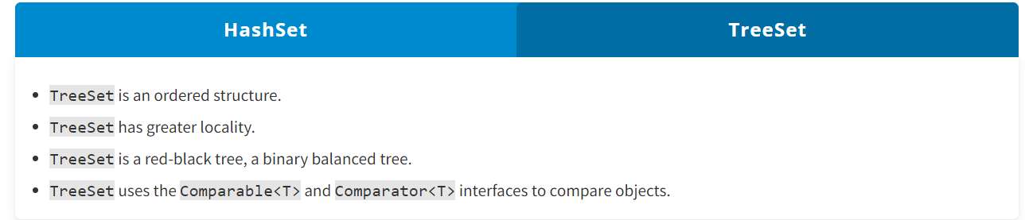

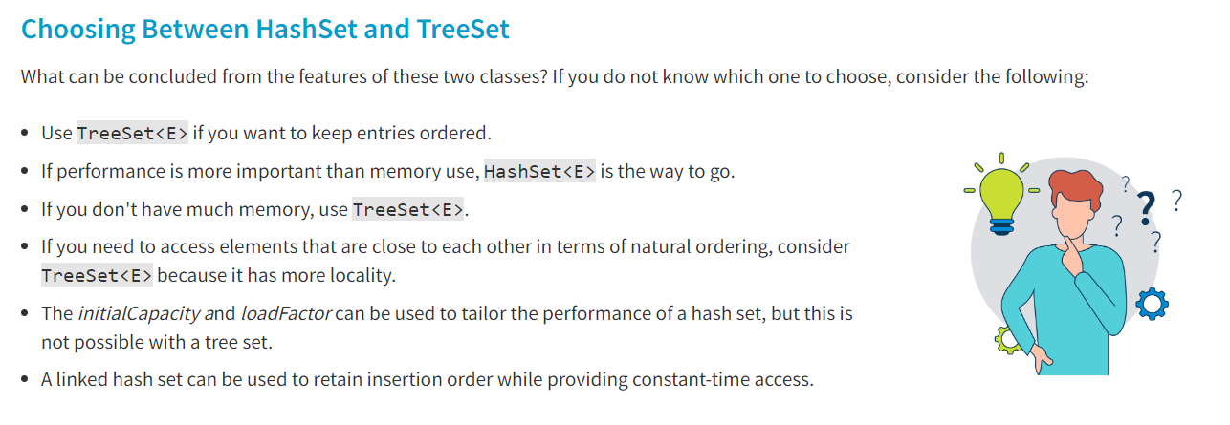

**Conclusion**

In the collections framework, sets are described by the Set<E> interface. This interface has two basic implementations: HashSet<E> and TreeSet<E>. HashSet<E> is an unordered hash table-based data structure that creates lists to resolve collisions. TreeSet<E> is an ordered data structure based on a red-black tree. If fast access to elements is important to you and ordering is not important, choose the HashSet<E> collection. If order is important because it makes many operations faster, then choose the TreeSet<E> collection.

* Other Set Implementations :
* **Introduction**
* LinkedHashSet<E> and EnumSet<E> are two of the common implementations of sets in Java. Knowing how to use them will help you store records properly and work with enumerated elements such as days of the week. In this lesson, you will review some basic operations on these classes and see how they are implemented.

**The LinkedHashSet<E> Class**

LinkedHashSet<E> is a hybrid of the unordered HashSet<E> and the ordered LinkedList<E>. LinkedHashSet<E> is the inheritor of the HashSet<E> class. It is a hash table with a double-linked list structure that keeps record of entries in the order they were inserted. This allows **insertion-order iteration** over a set.

Here is the underlying structure of the LinkedHashSet<E> class.

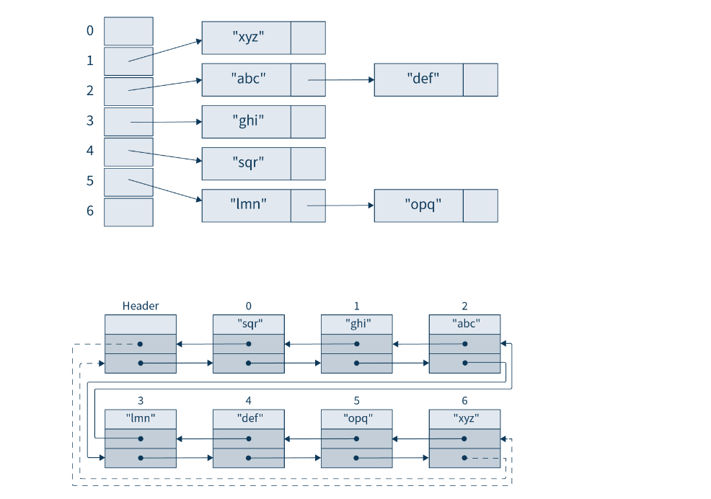

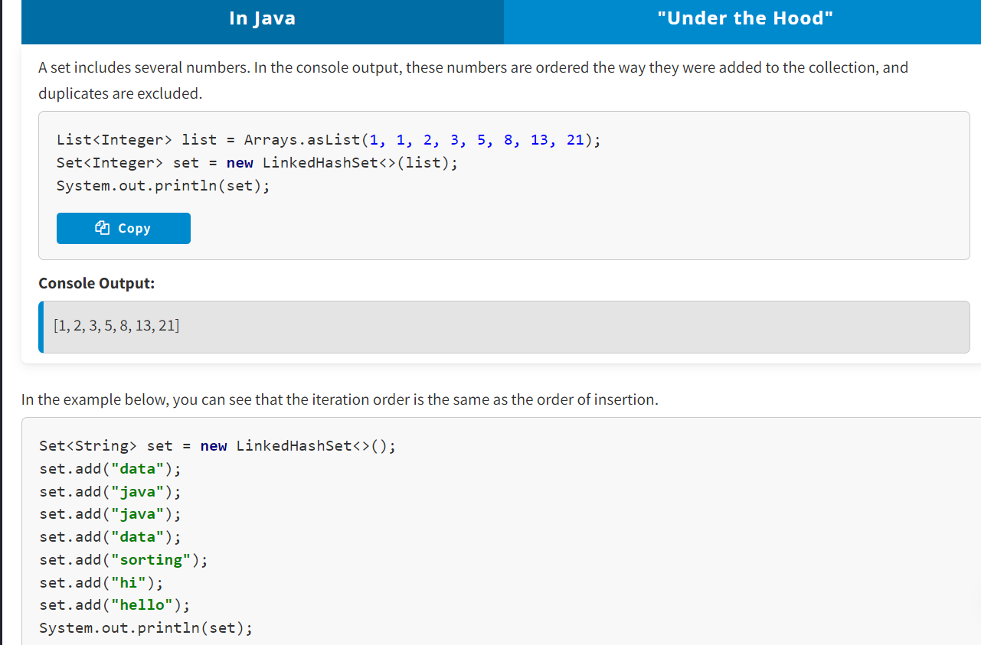

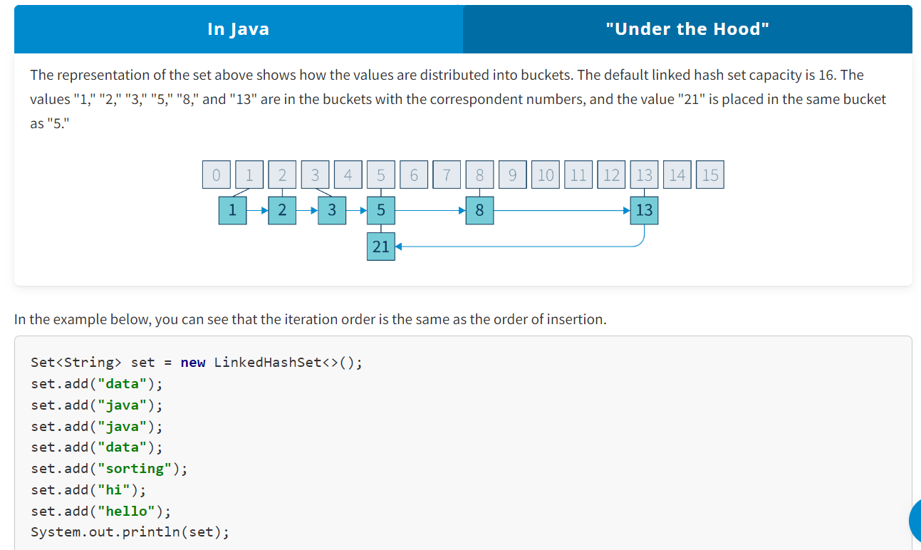

#### LinkedHashSet for Real-Life Tasks

The LinkedHashSet<E> class can be used for work with streams. If a stream passes duplicate entries, the LinkedHashSet<E> collection can help save only unique items and keep the order of their appearance. Another example is locating different words in a sentence, where the order of the words should be maintained as they appear in the text.

**The EnumSet<E> Class**

Another class in the set framework is EnumSet<E> class. It is an abstract class, extending the AbstractSet<E> class from the set framework.

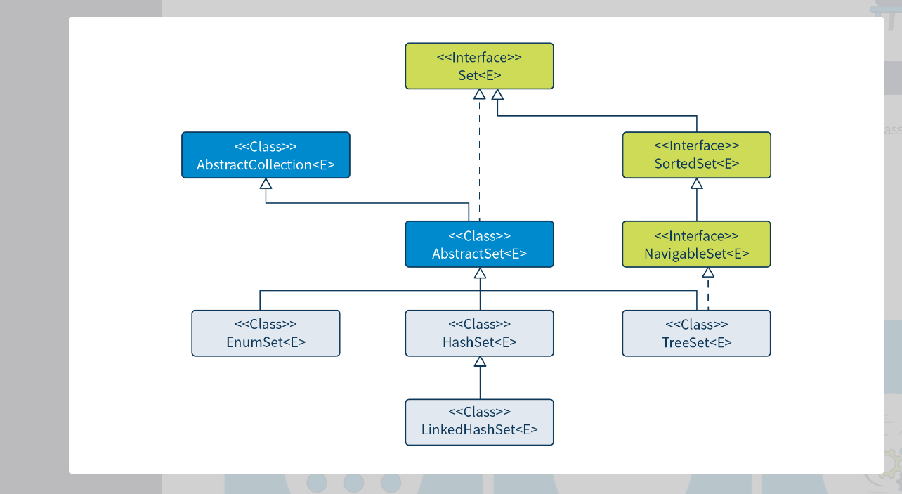

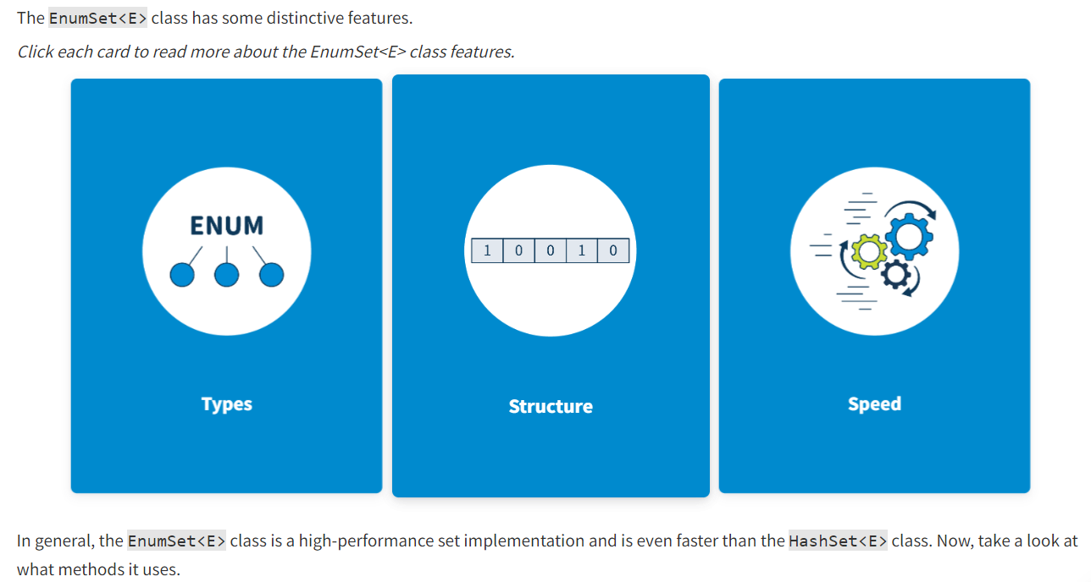

This class is specifically implemented to work with **enum** types. All elements of such a collection must belong to a single **enum** type that is defined either explicitly or implicitly.

Inside, the set is a bit vector or a long vector: a one-dimensional array. **Enum sets** support iteration over elements in the order **enum** constants are declared.

These operations are performed on such sets very fast, even if they involve many elements.

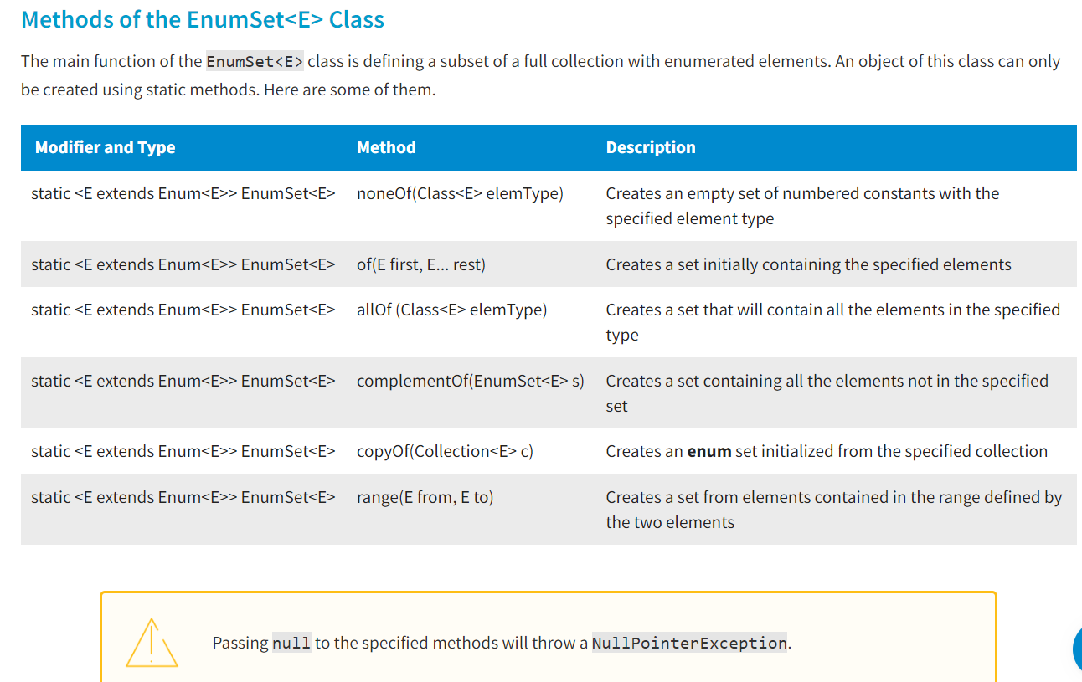

#### EnumSet For Real-Life Tasks

The EnumSet<E> class can be useful when working with something like a schedule. For example, you can set some operations implemented with workdays only, excluding weekends. Operations with currencies are possible too.

**Conclusion**

To sum up, the LinkedHashSet<E> and EnumSet<E> classes are implementations of sets with peculiarities. The LinkedHashSet<E> class provides element iteration in insertion order, while the EnumSet<E> class defines how to work with a set of **enums** more efficiently than a HashSet<E>.

**Introduction**

With Java, you can accomplish a wide range of operations thanks to arrays and specialized lists. Sometimes, though, a Java application requires something more like a database, but without the baggage of a database (such as the necessity to purchase a separate application).

You might, for example, want to be able to discover a given value in a list without having to look at each element separately. The map is a very handy type of storage container that simplifies many activities. In this lesson, you will get acquainted with the concept of a map, its properties, and methods of the Map<K,V> and Map.Entry<K,V> interfaces.

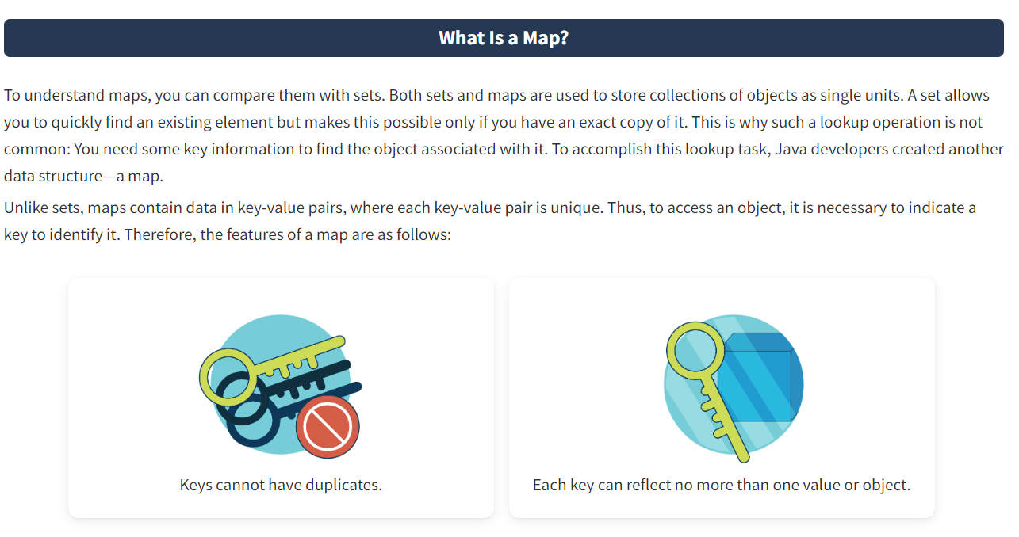

#### What Are Maps Used For?

Maps are great for mapping key-value associations such as in dictionaries, so maps can also be called **dictionaries** or **associative arrays**. Maps are used to obtain and update elements based on their keys

1) Maps are used to link error codes with their descriptions.  
2) Maps are used to link ZIP codes with the corresponding cities.  
3) Maps are used to link managers with their employees, where one manager oversees a number of employees.  
4) Maps are used to link classes with students, where each class has a number of students.

#### Map Implementations

There are three interfaces for implementing maps in Java: Map<К,V>, SortedMap<К,V>, and NavigableMap<К,V>. The classes implementing maps are HashMap<К,V>, TreeMap<К,V>, WeakHashMap<К,V>, LinkedHashMap<К,V>, and Hashtable<К,V>. The most commonly used implementations of the Map<К,V> interface are HashMap<К,V> and TreeMap<К,V>. Here is what the map framework looks like.

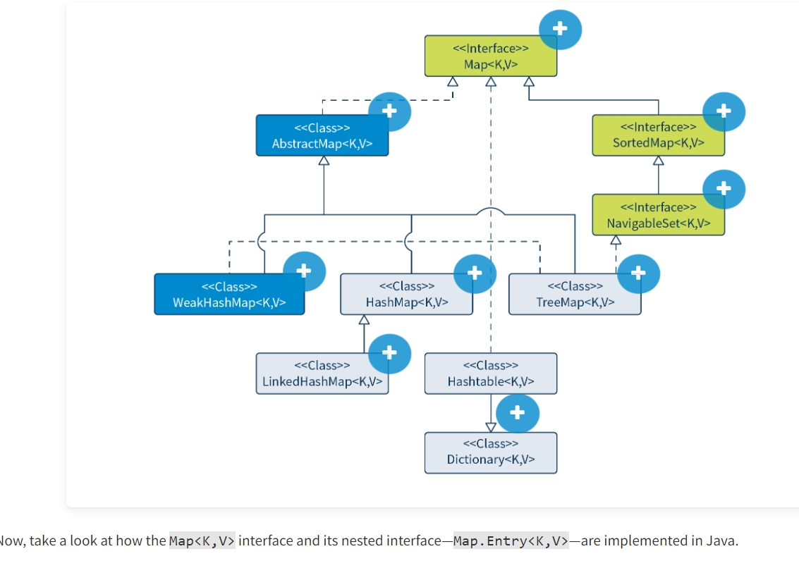

**Interface Map<K,V>**

This interface describes the behavior of a dataset represented by key-value pairs.

**Class AbstractMap<K,V>**

This is a skeletal implementation of the Map<K,V> interface that aims to reduce the effort needed to implement the interface.

**Interface SortedMap<K,V>**

This map is inherited from Map<K,V> and ensures total ordering of its keys.

**Interface NavigableMap<K,V>**

This interface is inherited from SortedMap<K,V> and allows the most relevant matches to be returned for the specified search targets.

**Class WeakHashMap<K,V>**

This is a Map<K,V> implementation that contains weak references to keys. When a key is no longer being used, a WeakHashMap<K,V> entry will be automatically deleted during garbage collection.

**Class HashMap<K,V>**

This is a Map<K,V> interface implementation that is based on a hash table.

**Class TreeMap<K,V>**

This is a NavigableMap<K,V> implementation that is based on a red-black tree.

**Class LinkedHashMap<K,V>**

This is a Map<K,V> interface implementation that is based on a hash table and a linked list.

**Classes Hashtable<K,V> and Dictionary<K,V>**

These classes are obsolete and not recommended for use.

**The Map<K,V> Interface**

The Map<K,V> interface has methods for processing data in the key-value format, where a key is an object or some information used to search for and retrieve a desirable object (value).

Please note that the Map<К,V> interface does not extend the Collection<E> interface. This means that elements of a map collection cannot be iterated over.

Most methods of the Map<K,V> interface are methods for working with a set of data in pairs. For interacting with a single pair, the Map<K,V> interface has the nested Entry<K,V> interface.

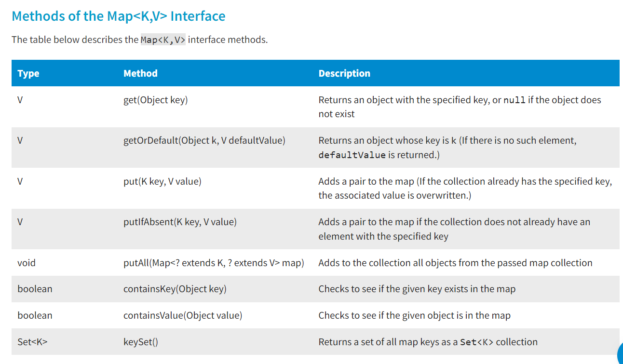

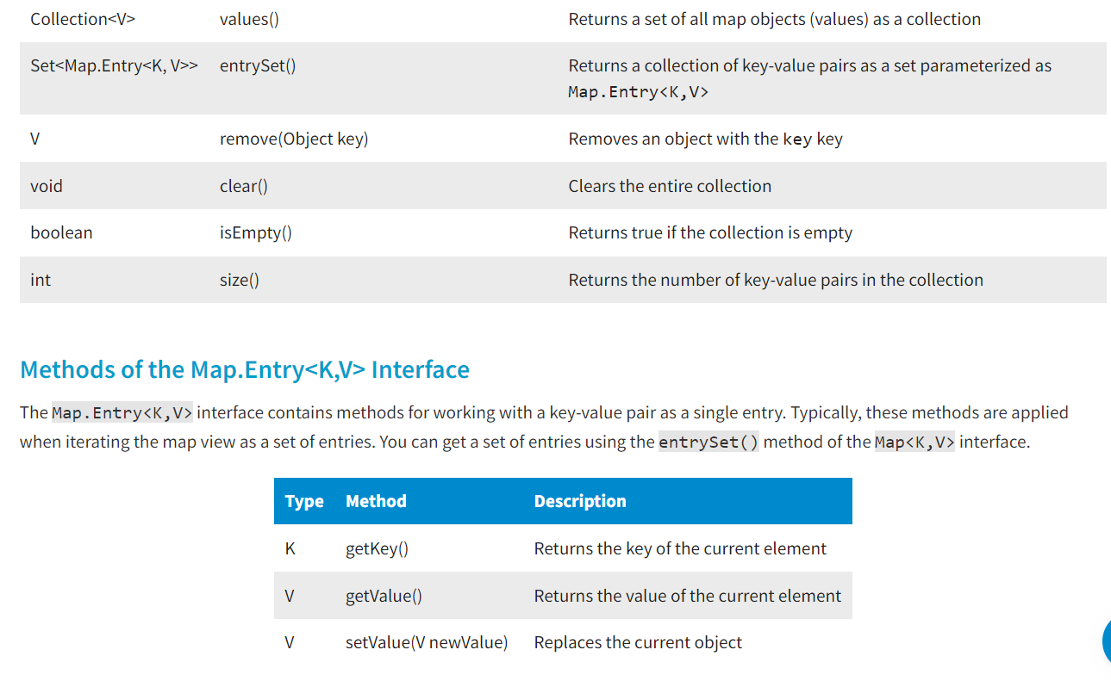

**Conclusion**

The collections framework includes interfaces and classes representing map implementations. The main difference between maps and other collections is access to data based on some information, i.e., keys. This is why the Map<K,V> interface contains general methods describing basic operations with maps, and allows obtaining a map representation in the form of other collections. Also, this interface has a nested Entry<K,V> interface for working with key-value pairs. Knowing the behavior described by these interfaces, you will be able to use maps efficiently.

**Introduction**

Rarely does a Java project not use hash maps. They are the workhorses of the java.util package and have the most prominent data structure for grouping and joining data as in a phonebook or a dictionary. In this lesson, you will get acquainted with hash maps and the HashMap<K,V> and LinkedHashMap<K,V> classes that implement them, as well as how operations on these classes are performed.

**What Is a Hash Map?**

Hash maps are based on a hash table data structure. They are similar to the Hashtable<K,V> class, but most of them do not have internal synchronization for safe use in a multi-threaded application. Hash maps also allow for the storage of null keys. There can only be one null key, but an unlimited number of null values associated with different keys. A hash map is an unordered collection because the order in which its elements are stored depends on the hash function.

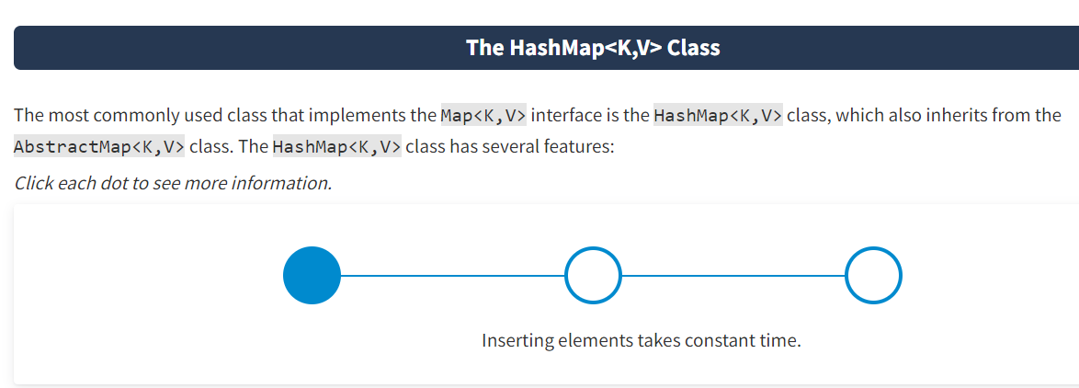

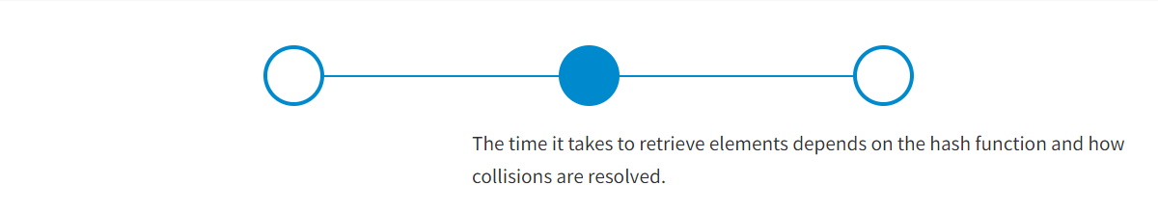

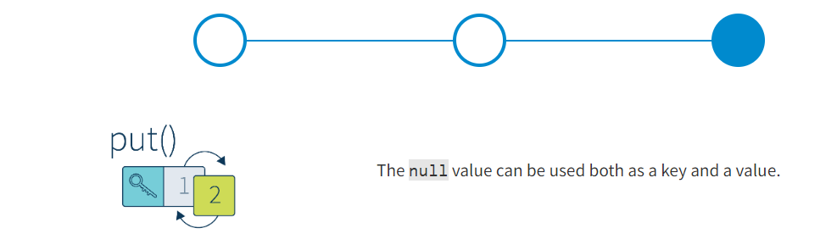

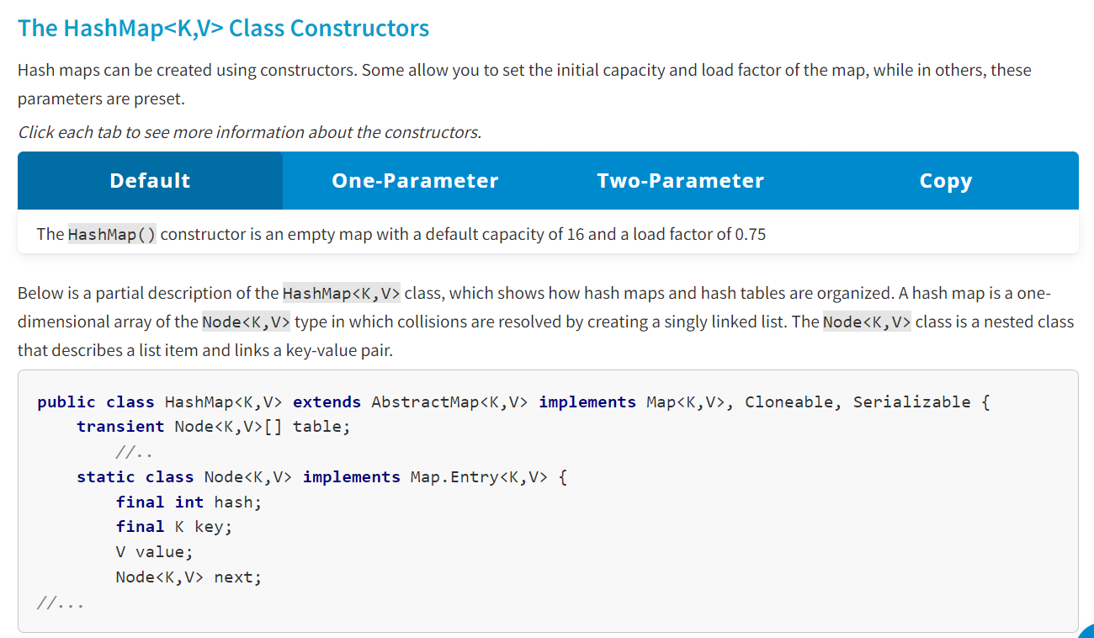

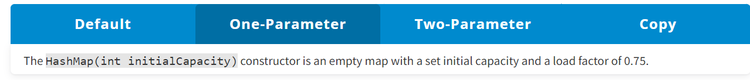

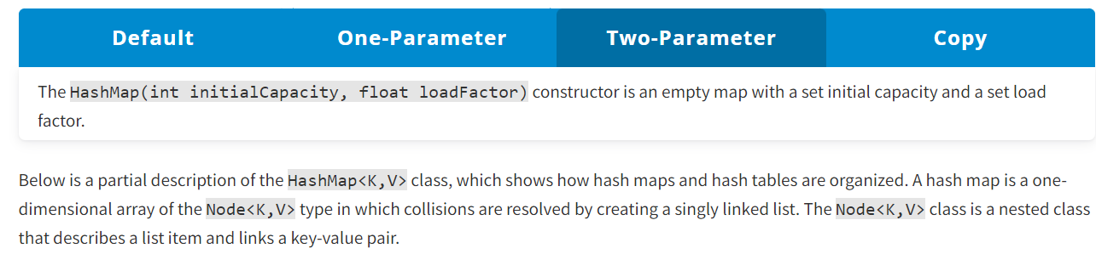

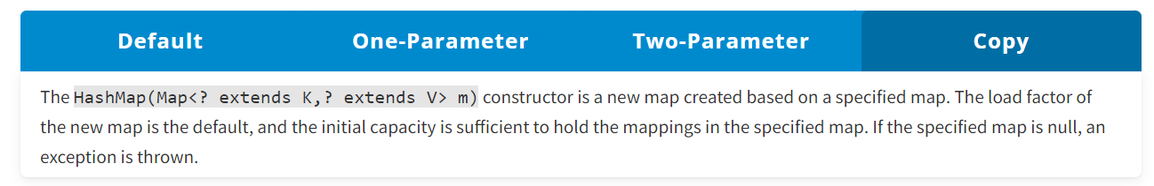

The following example shows how the HashMap<K,V> class can be used. An empty map with an initial capacity of 5 and a default load factor of 0.75 is created. The map is parameterized with Integer for the key and String for the value. Four pairs are added to it, and then they are displayed in the console. Unlike in other collections, elements in maps are listed in curly brackets, where a key and its associated value are specified with the "=" sign.

Next, a pair with a key of 2 is added to the map. Such a key already exists in the map; therefore, the value associated with it is replaced. You can see that it is reflected in the console output. The get() method is used to get a value linked with a key of 2.

To iterate through a map, you need it to be represented as a set of key-value entries first. Using the entrySet() method, you will get a collection of the Set<Map.Entry<K,V>> type. Then you will get an iterator for this set and, using a while loop, iterate over the entries. For each entry, use the getKey() and getValue() methods to get and display the key and value in the console.

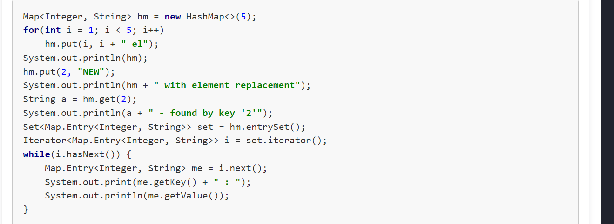

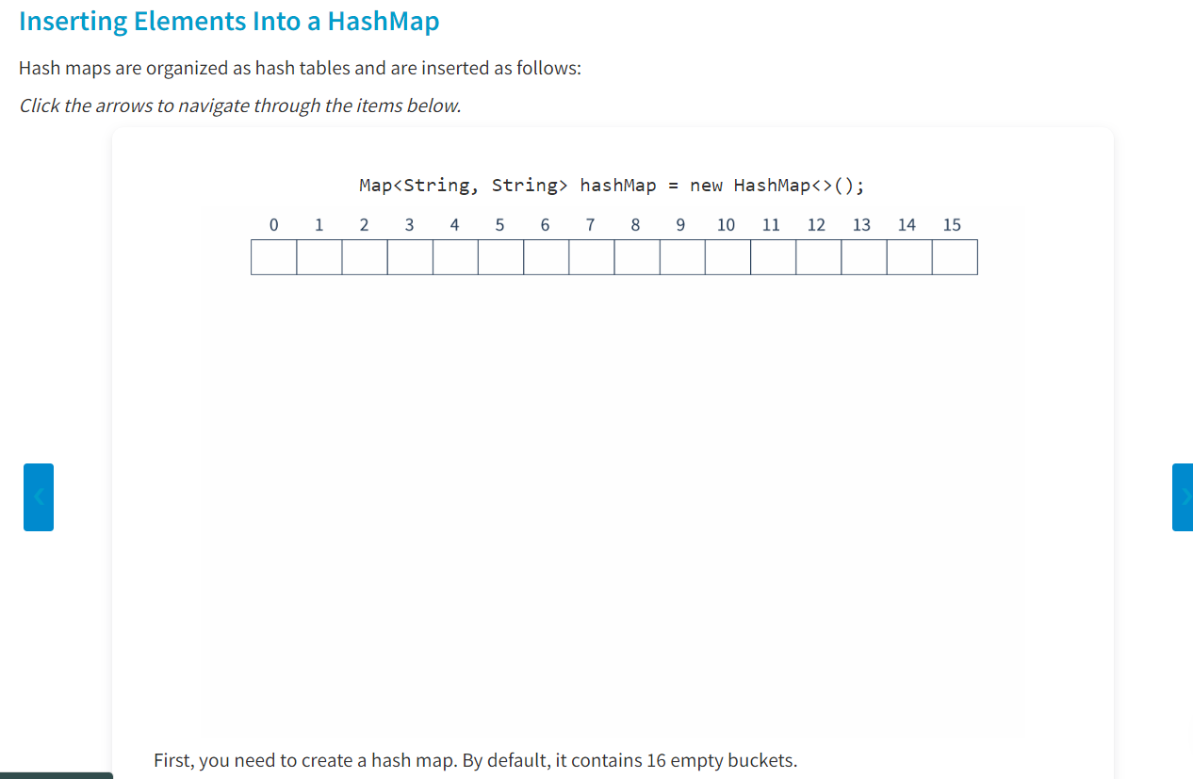

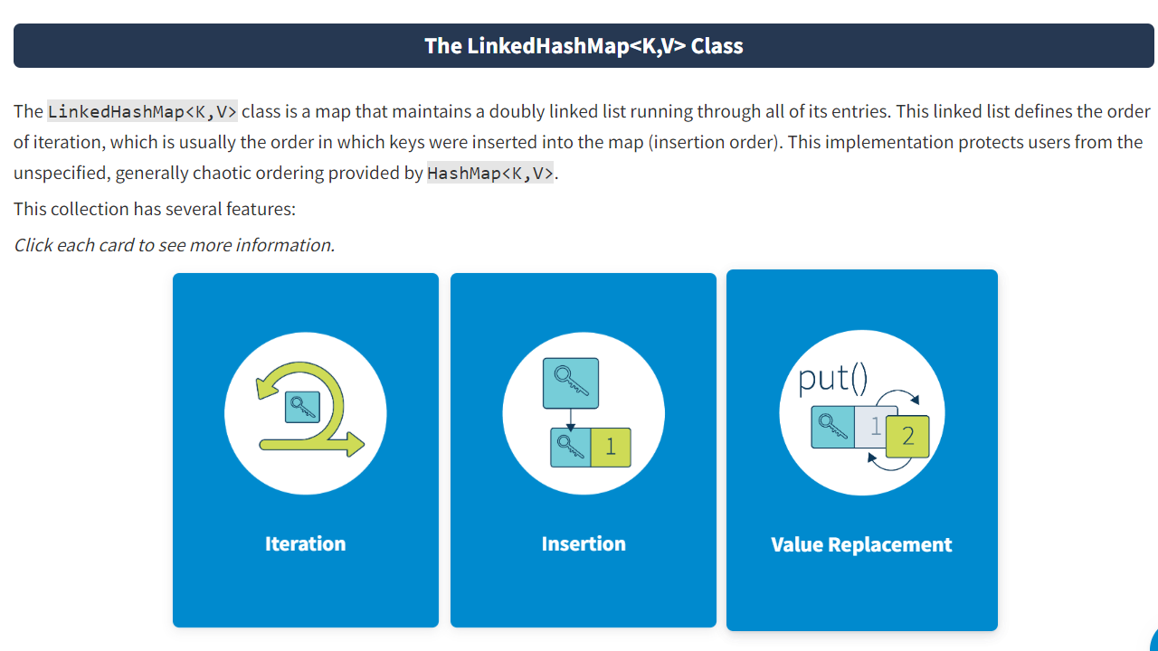

**Introduction**

The order of elements in a collection is important, and various implementations exist to allow you to find the right fit for your purposes. When using maps, it is vital to consider the order of keys. In this lesson, you will review the purposes for using the SortedMap<K,V> and NavigableMap<K,V> interfaces, how the TreeMap<K,V> class is implemented, and how tree maps are used.

Legacy Collections :

**Introduction**

The history of Java includes many versions in which collections evolved over time. Despite the wide use of modern collections, older ones are still functional and can serve specific purposes. In this lesson, you will explore these older collections of Hashtable<K,V>, Vector<E>, Stack<E>, and Enumeration<E>, how they are used, and the differences between them and their descendants.

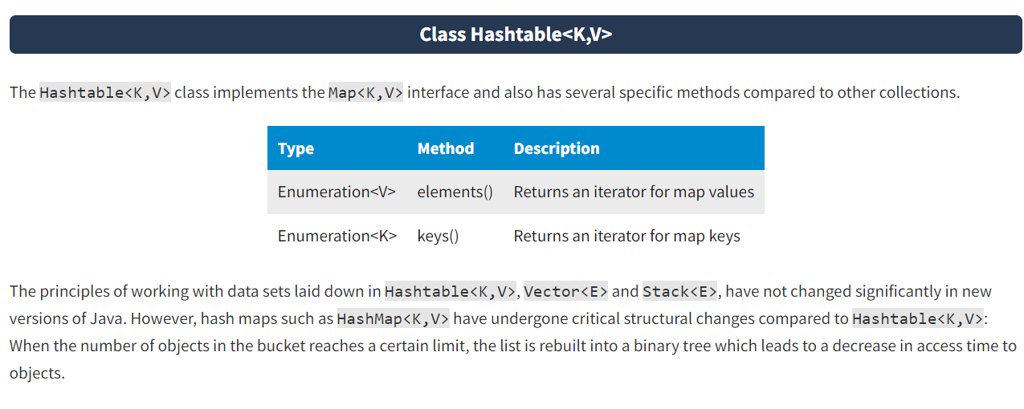

#### Interface Enumeration

Enumeration<E> is an interface used to iterate the elements of a vector, the keys, and values in a hash table. Its hasMoreElements() method tests if there are more elements to iterate over, and its nextElement() method provides the current element. The functionality of the Enumeration<E> interface is duplicated by the Iterator<E> interface, which has an optional remove operation and has shorter method names.

